THE IMPLICATIONS OF ARTIFICIAL INTELIGENCE IN DATA ANALYTICS DURING THE COVID-19

By
Name: Mr Rizwan Muzaffar
UB- Number: 19026341

2021
MSc. Applied Artificial intelligence and Data Analytics
University of Bradford

STATEMENT OF AUTHENTICITY AND WORDCOUNT

STATEMENT OF AUTHENTICITY

I promise that this work originally written by me, and there is no copy paste work mention in my dissertation. So previous work of other researcher has been cited with their name journal article and with proper referencing. So I learns a lot during developing the big data analytics model, so this work helps a lot for upcoming researcher that it gives a positive direction to all of the scientist with endowment. My supervisor helps a lot during all of this project that was very amazing experience.

WORD COUNT: 15000

THE IMPLICATIONS OF ARTIFICIAL INTELIGENCE IN DATA ANALYTICS DURING THE COVID-19

By
Name: Mr Rizwan Muzaffar
UB- Number: 19026341

2021
MSc. Applied Artificial intelligence and
Data Analytics

Dissertation Submitted to Bradford University MSc. Applied Artificial intelligence and Data Analytics

Abstract ID: ----------------
THE IMPLICATIONS OF ARTIFICIAL INTELIGENCE IN DATA ANALYTICS DURING THE COVID-19

Abstract
Corona virus rapidly increases during 2020 year and now the situation is under control, due to implementation of artificial intelligence based modelling technique. AI deep learning and machine learning modelling may be helpful for health department for taking decision and control situation and minimize the spread of covid. Convolutional neural network model is highly appreciated by the various researcher due to high efficiency rate of covid disease detection with chest x-ray image dataset. ARIMA model and LSTM model for forecasting the covid patient is also deploy and the predicting results of ARIMA model is very useful technique for making decision. Future research work is required to detect and predict real time scenarios of covid patient at public places. In this research primary data is used from Kaggle resource for making machine learning data analytics. Secondary data is used for findings the covid analytics and detection pattern. In this research no human being is harm and violate to misappropriation any dataset, all privacy concerned is maintained.

Table of Contents
Abstract 3
Chapter # 1: Introduction 6
AIM & Objective of Research 11
Chapter # 2: Literature Review 12
Introduction 12
Related Work 12
Conclusion of Literature Review 24
Chapter # 3 Methodology 25
Introduction 25
3.1 Research philosophy 25
Data Collection and Interpretation 26
3.2 Research Strategy 26
3.4 Data Collection Method 27
3.5 Data Analysis Method 28
3.6 Quantitative method 30
3.6 outcomes of research 31
3.7 Sources 31
Ethical Concern 32
Chapter # 4 RESULT & ANALYSIS 33
LSTM MODEL (Covid-19) Dataset. 33
Time Series Forecasting 33
Data Pre-Processing & Cleaning 34
Python Libraries 34
LSTM Modelling procedure: 35
LSTM Model summary 36
LSTM Analysis 37
ARIMA Model 39
Data Pre-processing & Cleaning 39
Split dataset 40
Data cleaning process 40
Split dataset on Training and Testing phase 40
Stationary Checking in the Covid19 dataset 41
Building the ARIMA Model Function 42
Analysis 45
CNN (Convolutional Neural Network) Model 48
Importing Python Libraries 48
Data Pre-processing & Cleaning 48
Training & Testing dataset 48
CNN (Convolutional Neural Network MODEL Summary) 49
Analysis 51
Chapter # 5 Discussion & Conclusion 53
Discussion 53
Future Challenges of Prediction Modelling 59
Conclusion 61
References 62
Reflection 68
Research Experience 68
Teacher Meetings 69
Skills Development 69
Research idea & development 69
Research work process 69

THE IMPLICATIONS OF ARTIFICIAL INTELIGENCE IN DATA ANALYTICS DURING THE COVID-19

Chapter # 1: Introduction

The spread of corona virus disease at the end of 2019 it also label as (COVID19) which is pandemic situation all over the global. During covid19 pandemic the situation of healthcare services face many issues and challenges which is essential part of every country to secure their situation of infection. The need of invention to invent a secure vaccine that used to treat the patient without any more vaccination. There is need to development of vaccination to organize the pandemic situation with transform healthcare department with advance clinical services to control and manage the system with proper implementation of health system. Various healthcare department takes decision with their own experience to deploy the system which includes the services to control & manage the covid patient, different digital health solutions has been established by the various countries to overcome the situation. (Visva, et al., 2021), the systematic approach carried out to identify the possible relevant intelligences their findings show that the large evidence collected through the different clinical experiences which identify the operational applications of tele health about to 41% the large number of investigated applications of artificial intelligence to overcome the situation by using big data analytics during pandemic situation, the large amount of reports which used to investigate the application of artificial intelligence about 45% to more big data analytics with ratio of 36% to evaluate the weaknesses of the study where is problem exist. Their investigation about to describe the application of internet of thing about 3% by using the digital platform to communicate with dc component of digital solutions for data management is 1.6% to translate the digital application of healthcare department by using the artificial intelligence based technique and methods. (Modgil, et al., 2021) Discussed that the importance of supply chain management to develop business application, supply chain about to develop resilience developing application of visibility, risk, sourcing and distribution, explored with their large amount of datasets to evaluate the big data analytics, their finding about supply chain system such as photograph, safeguarding last mile delivery, offering personalized solution, with upstream and downstream supply chain stakeholder.

(Hussain, et al., 2021) Entire world is making efforts to develop the vaccine for covid19 disease which rapidly growing in advance manner. The achievement of vaccine discovery still in under investigation stage, about the crucial development of covid19 waves on after periodic which enable the administration department to collect related vaccination requirement that up to the necessarily cooperate with general public platform. Their achievement about to discover the situation about the covid19 pandemic discovery which related to immunity of covid19 vaccination. The objective to develop artificial intelligence based approach to analyze the public analysis including social media platform in the United Kingdom and United States of America towards the discovery of covid19 vaccination. Methodology to collect data about 300,000 social medial related posts of covid19 speared with lack of vaccination including 23,571 Facebook posts in UK, USA. These factors analyzed with big data analytics tools such as python and R programing platform to investigate the development of artificial intelligence discovery. Results obtain in their investigation about to with positive and negative sentiment analysis about 56% to 69% accuracy to identify the results set of covid19 patient using UK and USA dataset.

(Kaur, et al., 2021)Global situation observed during the covid19 pandemic the currently investigate the huge risk of public health and safety to optimize the system with different tools and technique which identify the technical approach which used to evaluate the infection spread. The optimized method of consistent pressure to identify global healthcare system which navigate the equipment of medication that produced with high quality interface of identify the equipment. AI based tool is used to identify the spread of covid and take decision according to the situation. The technical aspects of individual that likely pretend to analyze the future prediction and tracking the currently status that produced the result which measured the calculation according to the infected patient all over the world. The confirmed recovery to identify the tracking policy of the future patient. Measurement has been taken frequently to use the big data analytics which regulate the international and national data system. Artificial intelligence technique has been widely used in all public health sector to save time, cost, and disease management with proper investigation. The formulation of physician assistance with high quality of workloads and workflow which produces high computing efficiency to compute the radiology imaging with given dataset. They identify the SARS COV-2 positive and negative groups that review the supplement process of vaccine development, disease management, they identify the process of vaccine development with use usages of pandemic situation, patient records. (Nougeria, et al., 2021) Corona virus disease spreading more likely in the mid of 2020, the effect of time sensitive with dataset to quantify the ratio of covid19 patient. Method of data collection using social media content by the artificial intelligence based technique to measure the neuroimaging data on the suspected patient with 97 hospital data collection in 20 US states. Their finding show that the number of computed tomography angiography CT perfusion with large vessel occlusion to identify the disease per sample on each day.

(khan, et al., 2021) the applications of artificial intelligence in fighting with covid19 to investigate the overall system using machine learning and deep learning methods which is highly recommended by the researcher to process large datasets. The focused of covid19 screening, diagnosing predicting and drug producing. Covid19 effect the global economy very badly that reflect to measures the quality of system. Various researchers investigate that the spread of covid19 disease with unnecessary development of data to identify the patient with no reason. The spread of covid19 disease spread by ignorance of public to meeting with each other without any reason. The comprehensive studies is used to identify the rules and regulation of system which used to evaluate the quality of patient and quality of patient, this report would be helpful for the public health department and public hospital which is part of system. The process of big data analytic discovery the system is able to identify the type of people which review and summarize the technology that used to pretend the system with vast discovery of big data analytics. They concluded in their research that machine learning and deep learning based approach is suitable to investigate the system of disease with covid19 dataset. Machine learning methods which used to identify the classify, predicting the patients age and disease performance, forecasting the results inspired by the current research items to produce the high quality framework. Concluded that the recent research about the discovery of covid19 spread show that scale up the paradigm of diagnosis patient. The relaiblitely of machine learning based algorithm to process complex tasks of big data analytics using the different terminology which used to cure the patient with vaccination and without vaccination. (Ginnekan, 2020) Investigated that covid19 x-ray machine is freely available introduced DeepCV19 net, the strength of covid19 that it was used to trained the model with almost 15000 images dataset , shows that the healthcare department organized in Chicago III region with radiographs by using AI based system which evaluate the dataset from one community hospital to other community hospital. These hospital part of public hospital interlinked with Govt public health sector. The AI based system which used to monitor at least 400 random cases with positive covid19 patient using the five radiologists to allow the direct comparison between the AI and expert system.
(Soltan, et al., 2021) Clinical resources of covid19 used to predict the disease driving presentation with hospital of viral-specific PCR testing with sensitive results that can take up to 72 hour to operate the reasons. The early detection of covid19 disease which used to detect the models for covid19 screening and disease of patient to attend the emergency department by using the suitable suggestion deriving by the software. The aim of development big data analytics by using the laboratory testing samples with blood pressure measurement that can be used to predict the validity of different patient discovery with different data items. The dataset has been taken place form different sources to validate the laboratory result with existing experiment. They trained linear and non-linear machine learning classification algorithm witch discriminate of patient disease by using the covid19 pandemics. Machine learning models classify the dataset by different prediction and by using the cross validation technique. Cross validation technique used to split the datasets into two groups like training part of data and testing part of data, training part of dataset may not be used for data validation but the testing part of data is used to predict the values , machine learning algorithm divides each data with frequency variable, like dependent and independent variable. Data extracted included presentation blood tests, blood gas testing, vital signs, and results of PCR testing for respiratory viruses, with covid19 dataset used to predict the patient health and virus quality it determined the quality of the patient that used to reflect the variability and with PCR-confirmed undecorated severe breathing condition coronavirus 2 infection were included in the COVID-19-positive cohort. Patients who were subsequently admitted to hospital were included in their respective COVID-19-negative or COVID-19-positive fees associates. They investigated 155 689 covid19 patient that reflect currently in hospital during 2020 period, they resultant show that the infected covid19 patient and serious covid19 patient ideally detected and managed through the base working of artificial intelligence and machine learning based technique. Their datasets show that about 77% of patient of covid detected which used to monitory cell and delivery the pandemic suggestion to use their quarantine strategy. The model is activated through the prediction strategies with reflection of the dataset.

(Adikari, et al., 2021) Covid19 pandemic which is deeply spread the intentions between the human societies. The public health with emergency that followed by the human life to control and manage through the instruction based method. Their studies focused on the deploy physical distancing which used to regulate the individual groups of covid19 that engage in different social activities. The internet mediated with communication of self-reported information which encapsulate the emotion health and mental health with different pandemic situation. (Bamidele, et al., 2021) Occurrence of covid19 disease calculated the world data about the death tools rate SARS are distributed around the globe with spreading the negative impact over the public due to negligence of the administration. SARS is infected many people during covid19 first waves but the identification method is unable to rectify the performance of the SARS method. The AI methods remain understood as a main feature in classifying the danger of communicable illnesses in ornamental the predicting and identification of possible world fitness pressures. The sustained growth of AI aimed at the Covid-19 illness eruption consumes melodramatically better monitoring, analysis, nursing, examination, predicting, trace sprawling, and then medicines/injection manufacture procedure beside diminished hominid participation in treatment action. (Dong, et al., 2021) Novel cohort of info knowledge, signified through big data and reproduction intellect (AI) knowledge, consumes remained extensively rummage-sale in the deterrence, analysis, action and organization of COVID-19 as a significant rudimentary provision. Although the technology take place to identify the modules level approach with effect of artificial intelligence technique. The rise of artificial intelligence technology that emerged the world into a data science world due to increasing of dataset on priority basis. The tool to predict the evaluation between the systems to identify the common approach

AIM & Objective of Research

- Aim of this research to investigate covid19 discovery by using secondary data level approach.
- The aim of this research to investigate the implementation of artificial intelligence technology to predict, monitor, analyze covid19 patient with software based technology.
- The objective of this research to produce the python based big data analytics by using covid 19 dataset.
- The main objective of this research to make a python application to predict analyze the covid19 patient of worlds

Chapter # 2: Literature Review

Introduction
Chapter focused on the findings of the studies carried out in the past which help the researcher to understand core relationship between the variable of the studies and it also use for the understanding of theoretical framework.

Related Work
(Edem, et al., 2020) Investigate that the appearance of 2019 original coronavirus (COVID-19) that professed a pandemic situation all over the world. It would made an issue over the health systems and destroy economic, educational and other industrial state very badly. As the rapid broadcast surges by various approaches to tackle the situation between the stakeholders to deploy ground-breaking screening, detecting & diagnosing the COVID 19 cases between the peoples to deliberately associated with. Additionally the usefulness of computing models linked with the new industrial revolution technologies to achieve the desired results. Recommend that the nature inspired computing models that used to develop the big data and artificial intelligence technique to resolve this issue. Studies shown that the nature inspired computing models would be helpful for the patients of COVID 19 in the pandemic situation many other attention has been taken to reach the goals but still not to find success. (Raza, 2020) Proposed meta-analysis over the current covid-19 situation by using many published repositories (PubMed, Scopus, Google Scholars), their analysis helps the researcher to fight against the covid19 situation. They investigate that almost all world facing lock down under this crisis the situation is panic and more inactive cases happened, either the machine learning and artificial intelligence will be helpful or not for making social distancing and maintain quarantine between the covid effect people. AI and machine learning groups working with medical groups to meet the challenging that currently facing by the half of the world. Concluded in their studies that AI might be helpful for socio economic challenges and producing and predicting the result to meet the financial. (Kumar, et al., 2020) Their objective of research by using the technology like artificial intelligence and machine learning to contribute the covid 19 pandemic situation, they suggest that by using the modern technology framework it will works more effectively to achieve the goal. Author methods describes that modern technology would be beneficial for the medical staff for making social distancing, concluded that the ongoing process improve the people health to fight against this virus, if medication is effective , but still in under development stage. (Huges, 2020) Deploying a conceptual model for estimation of covid 19 patient by using big data analytics technique gathered data using online survey, they investigate that online survey is used to detect and monitor COVID19 patient, and cure the patient according to their health condition. By using real time monitoring and patient detection systems makes life easy for the medical. Collect 54,000 respondent to structure and model the problem.

(Bragazzi, et al., 2020)Explored that SARS_COV2 coronavirus is very dangerous reported by WHO department. Artificial intelligence with machine learning tools used to analyzing big data analysis, it will be helpful to monitor the pandemic situation with effects of covid-19 patient. The situation is out of control under the Gov. Organization and private medical health department cannot take any bogus decision, with the potential increases of big data analytics which will be more challenging to the entire world community. Suggest that handling this situation big data analytics using machine learning technique is good to manage and treat the patient. (Rahmiatahzadha, et al., 2020) Highlight in their studies that convid19 impose a negative impact on medical science due to lack of confidence in the vaccination making. Covid19 patient needs extra care by using non-medication treatment under the quarantine segment. predict in their studies that AI based model is necessary to treat and protect the covid19 patient, their suggestion is more concretely about the machine learning based prediction technique is more useful between the medical researchers. Concluded that big data analytics for collecting covid data periodically after periods to make attentions towards the data science fields that makes more effective AI based algorithm to achieve the success goal curing from covid19. developed a three stages model such as input process and output was produced and the outcomes value in the personalized medicine with epidemiological data, their development part to predict is AI neural network, machine learning, deep learning and expert system is used in the ICU decision making included diagnosis, treatment and risk management.
(Pham, et al., 2021) Corona virus was founded in Dec 2019 Hubei china and it spread almost all over the world, and the situation is more tangible to protect. The death ratio of infected covid19 patient increased till July 2020, if calculated around the globe its measurable counts to collect the death ratio. They examined that the covid19 patient increased on daily basis and death as well, but there is lack of vaccination, that not yet confidentially developed to protect completely from covid 19. The examination of producing the vaccination is still in under supervision of china, Russia, UK, USA, Germany, Africa and Japan. Advise that to handle covid like situation the artificial intelligence and machine learning technique is more effective to control and manage over the online internet service. By using the intelligent robots, intelligent video surveillance for making social distancing between the people. Concluded that AI is effective technique for curing and monitoring the patient. (Mohammadou, et al., 2020)Propose that the AI mathematical modelling technique useful to cure the covid19 situation. The unexpected situations of spreading covid19 over the entire world community does not make attention yet at the community of medical field. The implement convolutional neural networks by testing on x-ray and CT images their dataset show that the aggregate case reported to surge the management strategies by developing the development of effective making of covid19 AI based solution.

(Naude, 2020) Findings was to show that the artificial intelligence is unique technique to fight against the covid19 pandemic situation. Meanwhile the occurrence of disease has been climb to custom AI. Their source of data suggest that artificial intelligence technique effective way to resolve this issue. Furthermore the AI could develop early warning and alerts, tracking and prediction, data dashboards, diagnosis and prognosis. AI technology can generate automatic alerts and generate red alert warning against the protection from the covid patient; it will also helpful for making vaccination to cure the covid19 patient more effective way. It also conclude that the AI still not effective to cure the patient yet, it’s used disadvantaged to lack of data either more data without any reason. System could not be able to manage & handle properly to make more effective technique to handle the covid19 patient. Recommend that future work is required for using AI more effectively established against the covid monitoring. (Mahalle, et al., 2020). The covid19 pandemic situation spend the short span but the importance is that to realize that what would developed to cure this disease effectively. Book was present perspective of covid19 towards epidemiological trait in the studies of covid19 protection against the virus, suggest that the predictions of covid19 by using the prophet algorithm indicate faster than other algorithm, these prediction is useful for Gov. Healthcare communities to approately measure this precautions before time. (Borra, 2020) Suggested that due to covid19 spread many governments organization can take startup to meet the challenges against the covid19 virus. Develop artificial intelligence apps which enable the medical staff and covid patient to overcome the situation by using the effective technique of application. The new platform which make use of unknown access for detecting Bluetooth technology and GPS service to enable the smartphone user that is being monitored during the quarantine monitoring. Application was also helpful to tracking the patient and monitoring with specific point, it handled the crisis which leads to success overemployment. In the view the datasets is being used during running this application such as post-corona virus age.

(C., 2020) Advise that AI based drones and robots is useful for curing covid disease and patients. These drone equipped with IOT devices that used random data to compute the analysis and make action. AI technology will be effective to predict the number of patients in different districts and locations. AI technology enable the big data analytics to develop effective algorithm for transmit the data across the edge and cloud. Investigate that how robotics technology is effective to fight against covid19. Introduced AI robotic technology network that is used on real time datasets to control, monitor and manage covid networks by using training testing methods of machine learning algorithm. (Barnawi, et al., 2021)The idea of effectively using machine and deep learning based model which creates the artificial intelligence application that deployed in the system to protect the covid patient from the disease of covid19 virus. Deploy artificial intelligence based model which monitor and organized the system effectively that relates to the methodology of AI based neural networks. System predict on real time with accuracy of 99.5% using many prediction models applicable on real time sensors technology. (Kharlamov, et al., 2021) Explored in their research the results of covid19 by using the IT technology that used to solve the conditions of covid19 pandemic situation. Used Russian covid19 data in their research to present the themes that relating to video hosting, social networks, microblogging, blogs, instant messengers forums, online media, print media & TV widely used in Russia during covid19 first wave. Data size about 85,493,717 which presents the different types of covid19 patient. Concluded in their research that by using online IT services is solve the covid19 situation as well. Forced that the artificial intelligence needs to deploy but yet is not any working appear to do this framework to solve the pandemic situation. Widely used the digital services that related to pandemic situation and spread the alerts messages to the remote areas by using online internet service and GSM service. Using Artificial intelligence in GSM mobile to spreading the covid19 messages all over the entire world which related to the tragic situations over the internet services.

Propose that the using of machine learning that relates to the collection of large amount of data to solve the large data analytics problem. It refers to identify the pattern in the datasets, machine learning algorithm based on artificial intelligence technique that solve the critical situation very easily. It map the problem in different categories and divides them to do the Meta data analysis by using the different dataset technique that related to the covid19 dataset. Submit that by using AI based machine learning technique it was widely used in the past to predict, analyzed and managed the covid19 disease. Concluded that AI based algorithm is used to solve many situation by using different categories of algorithm which relates to the situation by means to do the big data analytics. (Bansal, et al., 2020).(Jalal A, 2020) Suggest in their research that machine learning and natural language processing are widely used in big data analytics that can used to scan social media reports, scanning online data and detect localized disease and even they can reach the local pandemic disease situation. Canadian company in china successfully deploy machine learning based algorithm to detect covid19 disease (MA, et al., 2020)big data analytic using the machine learning technique has been widely used to detect the covid disease. It also detect car crowding everywhere the hospital situation by using the video surveillance monitoring, sentiment analysis is technique to solve the machine learning by using natural language processing technique. Unsupervised and supervised machine learning algorithm used to detect and solve the pandemic situations.
Explored in their research that many statistical modelling and dynamic predictive modeling technique used to predict the covid19 range, their tradition modelling approach describes that details of pandemic situations which related to the artificial intelligence based. AI is used to predict analyzed and suggest the pandemic situations to solve the problem during the time span of covid, it also used in very serious and critical situations to predict the modelling which related to the when the covid19 vaccination is being prepared and still in development stage. (SR, et al., 2019), (M.H & F, 2019) Modelling algorithm to detect Ebola virus that spread in china the effectiveness of four level government approach that related to the covid pandemic situations which determine the algorithm problem that can be determine the critical situation. The similar model also used to deploying the structures many situations. During the span of covid situation the idea of developing covid19 algorithm using machine learning prediction which classify the problems into different categories that much easy to identify the situation very easily. The time span of first covid19 wave it declared a lock down all over the entire world, the situation is much more critical to identify the covid19 virus, and all over the entire world community think about how to resolve the issue during the time span of covid19, many researchers widely used machine learning deep learning based algorithm to identify and predict the covid19 patient.

(Due & L, 2020) Indorse that by using artificial intelligence machine learning algorithm is one of best technique to solve predict and model the covid19 situations. The scientist of at John Hopkins University developed the covid19 prediction model, by using the covid19 datasets to predict the modelling which identify the situation and solve the problem of covid19 vaccination. Similarly developed comparison prediction model of different countries by collecting real time datasets from print and electronic media, they first pre-process the datasets in the programming language and identify the variables in the middle and predict the modelling by using the real facts in both of them. Determine classify and identify the datasets to determine the covid19 patient ratio for above age of 70 years of personnel. People are old and rare chance to survive during covid19 span, by using machine learning predictions algorithm which relevant to data sets that identify the age group of the personnel. Age groups of between 50 to 70 are infected very badly from the covid19 disease, the age group of 40-50 is just about 7% ratio for covid19 detection disease. The perspective and sentiment data collected from impact factor journals published at IEEE open access. Datasets was describes the age group of people for predictions of covid19 patient age group. The identification of age group was only possible through the machine learning & deep learning algorithm. Comparison of age groups which identify the problem that can be used to solve and identify the situation by using the comparison algorithm. Matching and comparison algorithm was best technique to different covid19 virus dataset, which related to covid19 first wave and second wave and even third wave of covid19. Datasets was deeply large and very complex to handle the situation, nonetheless the raw data only processed through the artificial intelligence based algorithm that identify the problem and its situation in many facts.

(K, et al., 2016)However the predictive modeling technique is now widely using in many countries by machine learning technology to analyze the large amount of datasets. Around it was an obstacle problem in 2016 for detecting Ebola virus in china and Russia, by less amount of information, the minimum length of datasets and less amount of comparison that never solve the issue, the issue has been addressed many times. Nonetheless the problem still not resolved. The world health organization is deeply working to resolve the issue addressed by the countries to resolve the Ebola virus issue, but the problem is still not yet provide the best solution to identify the nature of the datasets and algorithm strategies. (G.L, et al., 2005) Artificial neural network used to predict and identify the antigenic regions with high density of antigenic hotspot in the viral membrane of severe acute repository. Data is critical to deploy the predictions by using the different sets of platform, these datasets relates to solve and identify the problem. rapid scanning of different types of algorithm that identify the vaccination process of anti-body virus which makes problem in the entire body that not easily solve the issue. Machine learning technique also used in the previous era that exactly solve the datasets by identify the major components in between the datasets. problem of virus identification and it also relates to virus vaccination process that makes the proper vaccination process that determine the problem identification situation. (ASRS & JA, 2020) Covid19 case detection and identification that can used to predict and prevent exposures in the communities to develop the artificial intelligence technique to resolve this issue of pandemic situation, they investigate through the GSM technology by using mobile survey technique to identify the covid19 cases via the online internet prediction to collect different datasets which relates to identify the situation of covid19 patients. Identification of such cases in Italy that deeply affected with covid19 disease, the traditional methods of artificial intelligence based not yet completed the pandemic situation. covid19 identification methods by using the prediction technique in traditional sense to identify the process the covid19 overall effectiveness in different regions, how it’s reflect and how it could destroy the body of the human which does not relate to solve the problem by mean to success. Outdated modeling technology which does not identify the problem of covid19 patients from the datasets. New and revised machine learning algorithm now able to detect and identify the patients and type of disease from the given datasets, the datasets should be clear and concise. The datasets which relates to identify the problem by solving the situation of pandemic lockdown, by using machine learning neural networks method it deeply detect the each node and divide the each into different nodes and sub domain nodes. Neural networks nodes identify the datasets label which related to the patient virus domain and categories of virus that provides the actual nodes and different sets of age group and their disease span. Neural network is part of machine learning algorithm that developed from inspired by the human brain, it considering a deep learning algorithm that part of machine learning family.

(Analytics, 2020) AI and data analytics structures get together to solve large scale problems of healthcare department in any country. During span of covi19 first period many researchers developed various tools to track the activity of hospital capacity, and identify the patient risks so these technologies are critical to develop in the near future. Machine learning and data analytics are successful to production an important role in the development and process of large dataset. While developing the AI based algorithm the major problem to identify the actual working of prediction methods and identify the actual variable. Still these methods is under development stages that relates to identify the situation and problem solving technique. industry progresses by the working of machine learning based modelling and even the mutual working of healthcare department that works together to solve the problem of big data perspective. Website concluded remarks that protect with covid19 by attempting social distancing and if it attack the intuitive approach cure this virus issue from quarantine. (Dixon, 2020) describes that report their symptoms by using mobile devices and mobile browser that provides real time data to district health department in the collection of datasets. According to the web collected data from different regions to identify the pattern in symptoms, the cluster of symptoms that going down with passage of time span , recommended that we can cure this disease by maintaining social distancing, if the vaccine is developed but still precautions not attempted to deploy the methods. Concluded remarks of Dixon that we are unable to collect real time of covid19 patient, because people are working from home, people are busy to do their works from home, so system unable to collect such type of data that in reality describe the true sense working of datasets.
(Michael Dennis, 2020) recommended that during time span of covid19 it is much difficult to collect datasets from the country side location because these areas are isolated much difficult to collect data not available service of GSM cellular. Endorse that government should deploy internet services and GSM services on those areas which will be able to collect the dataset much easily as compare to other thing. (AI, 2021)Whereas the influence of AI and covid19 has been widely reported in the print and electronic media and it does not make any impact with AI technology usages. The importance factors to identify the patient activity and patient records in the ream time which relates to the advanced uniform of artificial intelligence techniques. The advent of AI and machine learning technology that boost up the business AI based technique to identify the augment decision making while making artificial intelligence based modelling it relates to the datasets. Uncertainty for developing the complete solutions using the artificial intelligence based technique to make the perfect algorithm strategies for developing the new technology.

(CJ, et al., 2020) Carefully determine the effected economy negatively at the lower attention to the government department to achieve success while determination of covid19 vaccination and monitoring hospital by using technology. Government is not achieve actual success rate from the given area of covid19. The usages of the technology it making the people success with determination of achieving the success rates. Author recommended that machine learning based modeling technique is used in china and Taiwan to solve the issue of economic crisis, they recommended that works from home for many educators and students that make their life easy in this tough time period. Similarly advise that many industries are being monitored by using artificial intelligence based modelling technique and it also working from their home as well. Artificial intelligence technique was really helpful during time span of covid19 period, by working from home and by monitoring the patient from mobile phone using the cellular dataset. The cellular is directly connected in real time by using internet service. Recommended to healthcare department strongly they monitor patient using live coverage of video surveillance on the particular effected areas. Advise that the technology is much efficient for solving complex problem and it’s also recommended the idea about the nature of the virus and time period of the virus life which and when remain in their body. Basically concluded remarks highlight that the proper curing this virus to make social distancing and make your body clean daily. (S, et al., 2020)Indorse that deep learning algorithm is much effective during covid19 predictions through using the covid datasets. Deep learning algorithm is applicable in every sense to apply on dataset label that identify patterns and infectious disease involvement in imaging results e.g. CT image and MRI image in the hospitals. The images is showing that the relations between the PCR-positive of the covid19 PATIENT , so these algorithm achieve great success in machine learning discovery to detect consistent amount of covid19 patient, so patient is detected in the image dataset.
(Elghamrawy, 2020) Discovered in their studies that corona virus disease contains nasal congestion, sore throat, cough, headache, fever, but the safety from the corona virus for making social distancing, it infect in commonly older people and older people chances of live is about to 2% probability so the infection of corona virus make sense on older type of people that does not look after their health. Planned diagnosis model which based on machine learning framework H2o for scalable processing the general adversarial networks and convolutional neural networks used to classify the results as compare to the experimental model of DLBD Covid then using the H2O framework for scalable covid19 classification. Numerous investigators established their models to diagnosis COVID-19 using Computed Tomography (CT) or X-ray imaging. In adding, an H2O’s Deep-Learning-inspired perfect founded on Big Data analytics (DLBD-COV) is future aimed at initial judgment of COVID-19 belongings using CT or X-ray images. Obtain results from the datasets for making imaging quality more better resultant it will show the quality of the imaging more concisely to relates these datasets to the machine learning prediction models. So these modules will be able to identify the model that produced by the deep learning based approach. (Punn, et al., 2020) Disastrous eruption of Plain Severe Breathing Syndrome - Coronavirus (SARS-CoV-2) also known as COVID-2019 consumes carried the universal danger to the alive civilization. Entire world community effected badly due to covid19 making the incredible efforts to meet the finance source data to risk life treatment and several other resources. The artificial intelligence researcher makes mathematical models to curing the covid19 patient by deploying the nature of the algorithm in true sense these model will be helpful for the community of health department. The contribution towards the wellbeing society their research recommend that machine learning based approach will be effective for the entire world community of health sciences. propose the machine learning and deep learning approach will be very effective to develop mathematical models for the medical science doctors that can able to achieve the success goals relating to the covid19 situation. Persuasively propose that deep learning algorithm widely used in many practices to solve many medical issues which achieve the goal of success.
(Wang, et al., 2021) Discovered that eruption of Plain Severe Breathing Condition Coronavirus 2 (SARS-COV-2) consumes produced additional than 26 million cases of Corona virus disease (COVID-19) world consequently distant. To regulator the disease of covid19 which produced the negative impact over the societies that does not related to the technology perspective. To manage the covid19 disease quarantine and by medical disease for curing the disease in the laboratory that generally sufficient to produce the standards that relating to the disease working. Founded happening COVID-19 radiographic vicissitudes in CT images, this study hypothesized that artificial intelligence methods might be able to extract specific graphical features of COVID-19 and provide a clinical diagnosis ahead of the pathogenic test, thus saving critical time for disease control. (Abdelhafid, et al., 2020) By using deep learning model for forecast for covid19 virus. Deep learning models can used to compare with other models which deploy the sense of making the datasets available for predicting, monitoring analyzing the datasets according to the given time period and time slots. used time series data that is collected from different countries like china, USA, Spain, Australia, and Italy, they developed effective deep learning model results for effectively deploy the covid19 data. Results show that the superior performance of variation auto encoder model. Advise that novel corona virus attacked almost all over the world, the public is not safe completely yet. Exactly, humble Recurrent Neural Network (RNN), extended temporary reminiscence (LSTM), Bidirectional LSTM (BiLSTM), Gated recurrent units (GRUs) and Variation Auto Encoder (VAE) algorithms have been applied for global forecasting of COVID-19 cases founded on a minor capacity of statistics. This study is based on daily confirmed and recovered cases collected from six countries namely Italy, Spain, France, China, USA, and Australia. Results demonstrate the promising potential of the deep learning model in forecasting COVID-19 cases and highpoint the larger presentation of the VAE likened to the additional procedures.

(Alazab, et al., 2020) advise that currently the corona virus disease exceeds due to ignorance of the people, the people cannot take serious about the vaccination process and the increasing ratio of corona cases on daily bases the datasets choose by the author collected from Europe, Italy and USA last year, they explored that the idea of making predictions algorithm by using the machine learning and deep learning approach to overcome this situation. The video surveillances method based on artificial intelligence technique and it should be rely on the datasets on real time collection. The real time data collection methods will be able to identify the people from corona virus cases and predict that the patient is still able to survive in this atmosphere or not. Machine learning is major concerns to analyze the big data analysis and making the prediction of covid19 disease. The prediction is possible to label the data items and divided the datasets to training and testing set. So testing and training part presenting as an x and y variable in the programming to make idea about the working of the covid cases. Data preprocessing technique is widely used in machine learning prediction by using python programming framework. This programing is one of the best machine learning platform language. Lastly developed LSTM model using Convolutional neural network and also develop ARIMA model with best accuracy about 94% of covid disease detection by using the dataset. successfully developed machine learning algorithm by using the artificial neural network and convolutional neural network. (H.H, et al., 2020) Investigate that covid19 disease for predicting the datasets more than 20000 people died first wave of covid19 disease without any precautions, they used first covid19 wave dataset. deploy a deep learning model to predict the corona virus cases. By using the machine learning algorithm and deep learning algorithm for detecting and make to produce the best accuracy. Develop LSTM model and RMSE model this model perfectly develop and to use to check the algorithm accuracy they also working to identify the machine learning based models. produced the results to check the accuracy of the covid19 datasets and analyzed them with best accuracy results. Resultantly the actual working of detecting algorithm is admired by the researcher deploying in their research to identify the dataset and working of algorithm. Machine learning prediction present the good result which will produced the big data analytic with best suitable format. By using covid19 analysis these methods will be more effective in terms of search and sorting the dataset. Describes the working of dataset which will evaluate the sense to achieve the better output.

Conclusion of Literature Review
Research work is carries to studies the past published material about to explore the covid19 disease datasets to analyze using the machine learning and deep learning predictions. Machine learning deep learning approach is one of the best artificial intelligence approach to identify monitory predict the covid19 disease. The following outcomes to process huge amount of datasets using machine learning algorithm:
- LSTM model using deep learning approach based on AI
- ARIMA model to predict covid19 patient
- RMSE model using deep learning algorithm
- CNN network to identify the datasets labels and prediction about the vaccination

Chapter # 3 Methodology

Introduction
Methodology of research supported out to developing the python based machine learning & deep learning covid19 dataset analysis. Research work is carries to studies the past published material about to explore the covid19 disease datasets to analyze using the machine learning and deep learning predictions. Machine learning deep learning approach is one of the best artificial intelligence approach to identify monitory predict the covid19 disease.

3.1 Research philosophy
It was happened on 2020 march that WHO world health organization acknowledged the covid19 situation was pandemic due to the corona virus disease effected by the SARS COV2 virus. World health organization directly measure the covid19 dataset on real time situation that was readily available through the social media alarm. So the dataset was collected from different sources and different web television. So the WHO collected dataset and take decision about to closure of everything in real situation. In the research collection aim to collect secondary data from the original peer-review articles related to the medical field of covid19.
The BMC medical research center collected the articles that was not been supported by the articles of journals standard peer reviews process overcome the situation the guest editors form the university of Croatia in Zagreb make the finding more effective. BMC reported that delays in reporting and publishing the result over the situation is more dangerous to handle the covid19 virus spread.
Epidemic proceedings frequently activate a flow of scientific experimental action meant on fast assessing healing before preemptive interferences. Safeguarding fast community admission toward the whole then impartial experimental best by the university professor to overwhelmed the pandemic situation. (Besancon, et al., 2021)
Broadly speaking overall open access peer reviewed articles available for data collection and analysis. Scholarly communication is freely available. Toward fix consequently examined data composed happening preprints then available COVID-19 investigation objects, by way of well as on retracted COVID-19 publications, in order to quantify subjects connected to studying period, struggles of attention, then unsuitable attention in the television.

Data Collection and Interpretation

During the pandemic situation data was collected on priority basis which should be available through the social media, television, and different survey conducting by the Gov. Organization. Covid19 cases increases in 2020 rapidly and the data ratio was higher as compare to other dataset. Researcher was start working on publishing research articles during covid19 in the year 2020, all of the science direct journals offer discounts to the scholars to publish material as on priority to meet the situation. In the research previously publish material has been used. (M & M, 2021).
Many research articles published and readily available on pre-print basis as on priority basis. The challenges for research publication during the pandemic situation was very easy to do the publication while measuring the research system. The situation of virus types SARS Cov, Mers Cov, Cov, till studying. The situation of vaccination discovery was starting on covid19 duration about to 3 month. Various covid19 vaccine introduced now the clinical trial about to end and the usages of covid19 vaccine properly medicated to the patient over the situation is under control.

3.2 Research Strategy
Covid19 sickness which was the global health warming message to transmit the viral infection produced by the severe breathing syndrome coronavirus 2 (SARS COV2) disease. The effect of covid19 disease spread by the different medical agent during the pandemic situation. The spread of covid19 disease in all over the globe its question mark over the medical scientist which was failure to meet the situation within time. In these days the SARS COV2 pathogenesis need to urgently formulated to organize the outbreak of the disease. (majid, et al., 2021)

With the appearance of the newly created severe acute syndrome corona virus 2 it is SARS COV-2 flashing global epidemic situation which was driven by the national treatment with the studies which proposed to handle the treatment method. Scholars strongly recommend the approach of national coordination that meet the criteria of randomized controlled trials RCT of corona virus disease. Recently pandemic situation and future pandemic situation concerned with major difference. The reflect of covid19 dataset has been collected from different region to analyzed the patient condition effected by the virus which was currently on clinical trials.
To discovery real healing choices aimed at COVID- 19, numerous methods to organization and ordering of scientific investigation consume remained occupied internationally. Nearly are additional than 3000 pertinent RCTs currently listed. The implementation method of research based on covid19 patient pretend discovery. The recovery method of patient introduced in this research, death method with cause of covid19 discovery also introduced.

3.4 Data Collection Method
Secondary Data:
Secondary data collected by using Google scholars and already published articles. IEEE journals article and the articles of information science and science direct used in this research as a secondary data.

Primary Data:
Covid19 dataset is used for python data analysis and predictions of death toll type of disease and life of virus.

3.5 Data Analysis Method
Machine learning and deep learning model for predictions of dataset of covi19.
Python Jupiter Notebook used for data analysis.
- LSTM Model (Based on Deep Learning of machine learning)
Commanding kind of neural network intended to grip arrangement requirement is named recurrent neural network. The long short term memory model which was known as LSTM model. This model was successfully train that used in deep learning modelling to predict and analyzed the dataset. LSTM model is variant, multi variant dataset to achieve the goal of data analysis method. LSTM model used Keras python library to predict the values between the dataset. It solves the problem of time series which was designed to manage the system with data driven approach. (Mystery, 2021), LSTM model used to predict the sequence prediction. Sequence prediction based on time-series forecasting with the help of deep learning library.
- ARIMA Model (Based on Deep learning library of machine learning predictions)
ARIMA model delivers another approach of time series data approach for time series predictions for complementary time series forecasting the ARIMA model extensively used by the many scholars for prediction of covid19 patient. ARIMA model forecasting individual element of dataset which relate to the problem variable. ARIMA models get more attentions as compared to other model like support vector machine and wavelet neural network. ARIMA model is combination of two model auto regressive AR., it was describe the covid19 death rates, mean square error, confirmed cases method and materials of dataset to be used to predict the covid19 patient. (Darapaneni, et al., 2020)
ARIMA model established by using the python, the model is reliable for the quality of fault tolerance and fault diagnosis. ARIMA models shows the numerical imitation which describe the fault occurrence stages of covid19 system. (Mu, et al., 2020)
ARIMA model is one of the best linear model of statically method time series forecasting of data that is also known as artificial neural network. ARIMA and artificial neural network also known as hybrid model. ARIMA and artificial neural network used hidden layer of neural network to achieve the goal of metrics. Data set is used to solve the complex problem of the covid19 discovery. ARIMA hybrid model is best prediction model to achieve the goal of data prediction. Neural network and artificial neural network approach was used to predict the different values of the dataset. (Suhermi, et al., 2018)
- RMSE Model
Due to the SARS Cov2 for the public health safety playing a crucial rule during the pandemic situation of corona virus. Actual Imitation Number (R_{t}), remain not continuously forthright to compute, levitation walls amid the technical public besides non-scientific executive performers, it’s a machine learning based modeling technique which used to forecast the decision making strength and assessing the plan of covid19 disease and its effectiveness over the usages. Auto regressive integrated moving average for each country that archives the information about the covid19 outburst. Using the prediction of the moving average to evaluate the ratio of disease over the strength of the population which describe the effective approach of the dataset. (ortiz, et al., 2020).
Root mean square error which works with LSTM model to predict and evaluate the values in the dataset. Analytical classical of the illness would assistance assign medicinal possessions and control community estrangement events additional professionally.
LSTM model with highest predict rate with low error, the level of frequency is much better than other model. LSTML model would increasingly smallest forecast mistake rates though following the event cases of republics. (Tian, et al., 2020)The prototypical presentation limits remain intended as mean square error, root mean square error, and reversion notch and fraction correctness. This model about to 97.7% accurate by using the dataset to predict the death cases recover and with average of confirmed cases about to 88% on daily basis. (parbat & Chakarborty, 2020)
- CNN (Convolutional Neural Network) Model
Convolutional neural network model is used to predict the number of confirmed cases by using the datasets of different countries. The covid19 corona virus prediction model has been done by using deep neural network system, it based on real prediction of the cases infected on corona virus disease. To apply the overall efficiency of the algorithm the root square error and root mean square error is used in experiment study. The convolutional neural great efficiency of prediction the covid19 cases. The model also predict the number of cumulative number of covid19 cases. (Huang, et al., 2020)
Convolutional neural network prototypical aimed at the involuntary analysis of COVID-19 illness after the torso X-ray imageries. After obtaining the results from the logistics regression prediction model the accuracy in the system obtain to determine the system more effective. planned CNN prototypical chains the discerning control of the dissimilar CNN`s sub-models besides categorizes torso X-ray imageries hooked on COVID-19, Usual, and Pneumonia periods. (ghour & Jain, 2020)

3.6 Quantitative method

Statistical analysis performed in this research by using the machine learning approach.
Analyze the death rates of covid19 patient, over the situation to meet the challenges of covid19 patient discovery which used to manage the entire situation of the patient during the pandemic situation. (Verbeke, 2021)
Numerical and statistical description of machine learning models which is used to determine the dataset of covid19 discovery which managed and organized through the dataset of covid19 disease of different region areas of the world, that is caused by the information in the initial stage to handle the relationship between the cause of death and cause of virus and situation of covid19 waves depends on the dataset. The rational of the dataset also predict to monitor the patient heath. Quarantine approach widely used by the globe to handle the pandemic situation that is caused by the corona virus. Corona virus which was predict and analyzed through the data mining and statistical approach which leads to the success rate of virus during the pandemic situation.
The occurrence of covid19 situation disease during the pandemic that was achieved through the globally health prediction swellings, by use of statistical modelling of machine learning approach that was widely used by the many research during literature review finding. Machine learning based predicting modeling technique by using the various deep learning libraries of python which was highly appreciated by the scholars. (Zou, et al., 2020)

3.6 outcomes of research
The research outcomes based on the dataset covid19 predictions. I usually outcomes of the overall research work. Covid19 prediction about the dataset prediction which used to predict the virus types and types spread over the word. What kinds of germs over the disease spreading, what are the outcomes of vaccination of covid19. . The following outcomes to process huge amount of datasets using machine learning algorithm:
- LSTM model using deep learning approach based on AI
- ARIMA model to predict covid19 patient
- RMSE model using deep learning algorithm
- CNN network to identify the datasets labels and prediction about the vaccination

3.7 Sources
The following sources used in research
- Google scholars
- IEEE XPLORE
- ACM Digital library
- Python Anaconda Notebook
- Python Pycharm tool

Ethical Concern

This research does not harm any human being, and does not violets any privacy issue. The concern of the research to model the dataset for predicting and analyzing the corona virus patient, type of disease and ratio of certain deaths. This research respect the scholars of published research, and does not affect research to violate any concern of the covid19 patient dataset. The resources used in this research contemporary the technology into modern fact. Resources can’t make any privacy issue concern. Many ethical concern point out to determine the accuracy of the results to evaluate and determine the death rates of covid19. Covid19 dataset is legally used from kaggle.com and it does not create any problem for the authority and any organization. Analysis method using machine learning algorithm the algorithm used in the given project relates to the ARIMA model, LSTM model RMSE, CNN producing good quality of this research. These algorithm increases the reading quality of the research. It will helps a scholars to future challenges.

Chapter # 4 RESULT & ANALYSIS
Deep learning based model used to predict the covid19 dataset, LSTM model used to predict the novel corona virus cases, the prediction was starting from early convid19 stage from 2020 onwards. Beside this the LSTM model built the good accuracy to point out the number of confirmed cases as well with the time frequency domain, these prediction based on time series analysis. The LSTM model variation based on recurrent neural network of deep learning model. The variation of dataset has to be acknowledge with the change of time domain frequency depends on the level of system. LSTM model with least mistake is selected aimed at forecasting every day and monthly cases. It is considered that the accuracy of LSTM model is good to choose the predicting the accurate results that relate to the deficiencies of predicting the covid19 cases as per the requirement of the Gov. Sector. Mostly the covid19 dataset has been handled by the Gov. Agencies. To produce the accuracy result with best consideration that leads to the time series forecasting analysis, Covid19 control and mange with this predicting model. Because LSTM model provide the facilities to predict the Covid confirmed patient cases with the time series pattern. (Anoushi & Chawaki, 2021).

LSTM MODEL (Covid-19) Dataset.

Time Series Forecasting
COVD-19 dataset has been downloaded from the Kaggle web site. Dataset need to be cleaning and pre-processing phase.
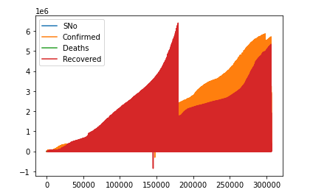
Figure: plot the dataset
Steps to perform the LSTM Model in Jupter Notebook Python:
Step 1: importing python libraries:
Numpy, pandas, matplotlib.pyplot
Reading csv file dataset contains covid19 dataset, download from kaggle website. , after reading data, display data heads, to check any missing values and remove them. So there are 4 fields in the dataset, SNo , Confirmed, Deaths, Recovered. Plot the dataset to visualize them.
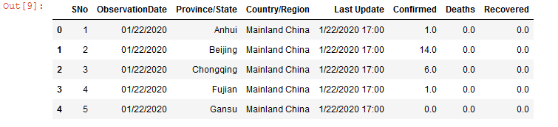
Figure Fields of dataset.

Data Pre-Processing & Cleaning

Data is normalized after feature scaling of the dataset. So there are 4 fields in the dataset, we required only two fields, so in the data pre- processing steps dataset is normalized to choose the only two variable such as Confirmed covid cases and number of dates of covid19.

Python Libraries
Import tensorflow and keras, sklearn, library in jupyter notebook to perform data preprocessing method by using the python machine learning algorithm.
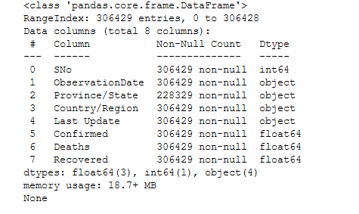
Figure: data preprocessing values
Number of columns and rows after removing missing value in the dataset
Print the time series dataset range with start dates to end date to validate the dataset values.
Split data set into training set and validation dataset test.
Transforming the dataset for tensorflow keras, after selecting the library and select only two fields of the dataset to perform the LSTM modelling. Plot the seasonal statistics model of the fields. Trend, seasonal and resid values plot. Train and test data with min max scaler.

LSTM Modelling procedure:
Importing the time series generator keras libraries, selecting independent variable and dependent variable to generate the x and y variable feature.
Import the following LSTM libraries:
- Import sequential model
- Import DENSE library
- Import LSTM model library.
Selecting the 200 features from the dataset to validate the dataset values. And printing the LSTM model

LSTM Model summary

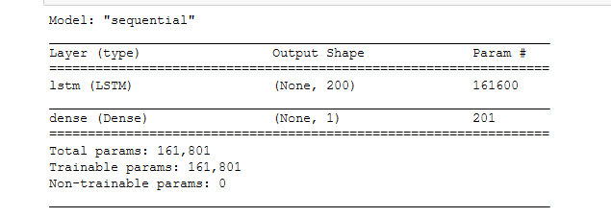
Figure: LSTM Model Summary
Mean Square Error of LSTM is :
RMSE : 75

Import seasonal statistics modeling the following output is below:

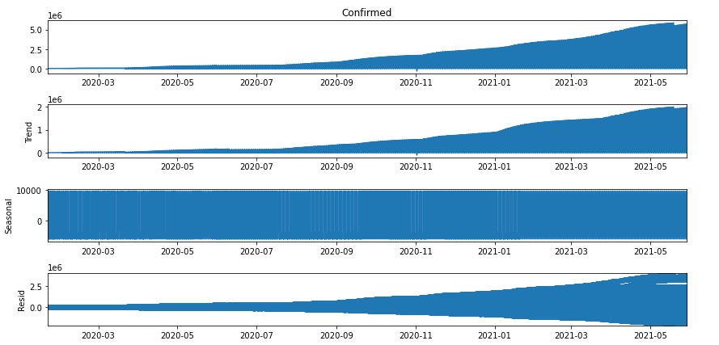
Figure: Seasonal Statistics model

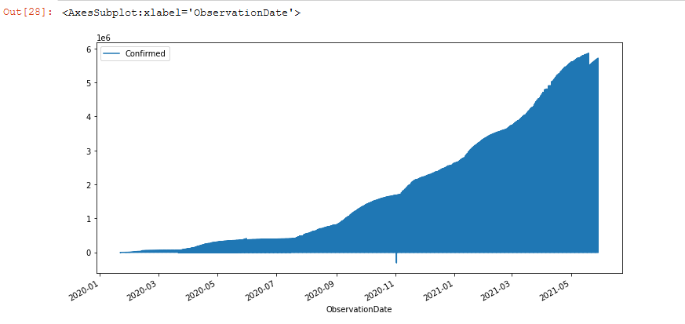
Figure: confirmed covid19 cases values
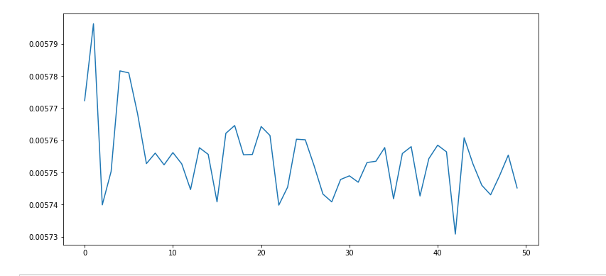
Figure: Loss Epoch, model history plot

LSTM Analysis
Convolutional neural network and long short term memory LSTM model is recommended by the scholars for making sentiment analysis of dataset. For dataset classification schemes LSTM model is mostly suggest by the different scholars, beside this deep convolutional neural network has been highly effective in local feature selection while other recurrent neural network often develop good result. The LSTM model is used to big data analytics for making the big data in more organized manner. Keeping the scalability of the feature in more effective way to analyze the data modelling, for convention machine learning modelling, the result has been carried out to train and test the dataset modelling after feature selection of the given dataset, the experiment results show that the modelling procedure is good to view the determine the covid19 cases in order to time series modeling that reflect on specific date value. (Behera, et al., 2021).

The ongoing covid19 cases increases confirmed covid19 cases reflect on different time domain series, increasing cases of covid19 differ from death cases, it depend upon the age factor of the human. The method of covid19 confirmed cases detection the pervasive computing is recommended by the different scholar, dataset has been collected from the digital smart devices, and analyzing disease value with different parameters. Author collect data by using the smart device technologies with infrared thermometer HIK vision thermographic camera for covid19 patient confirmed cases detection. Mathematical modeling to classify the covid19 cases such as recurrent neural network with long short term memory is used to analyze the covid19 cases predictions. Machine learning based prediction is highly appreciated by the most of researcher in their research due to AI based algorithm for detecting predicting the modeling. And to classify the clinical trials with respect to the nature of the dataset different mathematical and statically model is used to analyzed the dataset. (S, et al., 2020).
Long shot term memory LSTM model developed to predict the future forecasting of COVID19 cases, it also predict and classify the covid19 confirmed cases and death cases depends on the dataset and the age group of people. Possibly the outbreak of covid19 cases in the year of 2020 and 2021 has been predicted and analyze with different machine learning frequency domain at Italy and Canada. Dataset frequency to determine the confirmed cases about to 2, 4, 6, 8 values in the given dataset. The forecast of LSTM model to predict the covid19 cases and analyzed them with different time series frequency. (Kumar & Zhang, 2020)

ARIMA Model

Data Pre-processing & Cleaning

Step1: importing the python libraries for performing the dataset to be organized according to the validation set and testing part of the data pre-processing system.
Following python libraries:
Import OS, Import time, import pandas as pd, import numpy as np, matlplotlib.pyplot, import warnings, import warning. Filters, import seaborn as sns, from pmdarima.arima import autoarima , plot style seaborn.
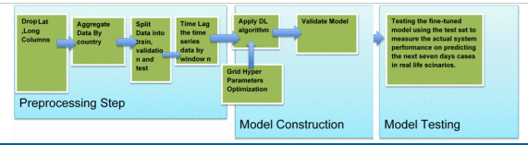
Figure: ARIMA model pre-processing

Statistics value of dataset as follows:
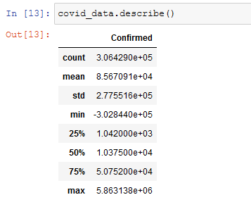

Split dataset
Dataset is split only two phases such as observation date and confirmed covid19 cases. It depends on the time and date of the given dataset.

Data cleaning process
Removing null values if exist in the dataset.
COVID Death pattern plot as follows:
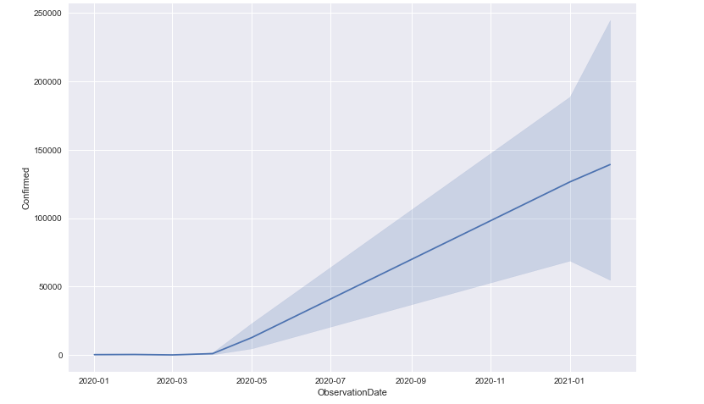
Figure: Death pattern plot of covid19 confirmed cases

Split dataset on Training and Testing phase

Dataset training phase and testing phase. 85% portion of data split
Testing phase of dataset is about to split in -20%
Plot the observation data and confirmed cases as follows:
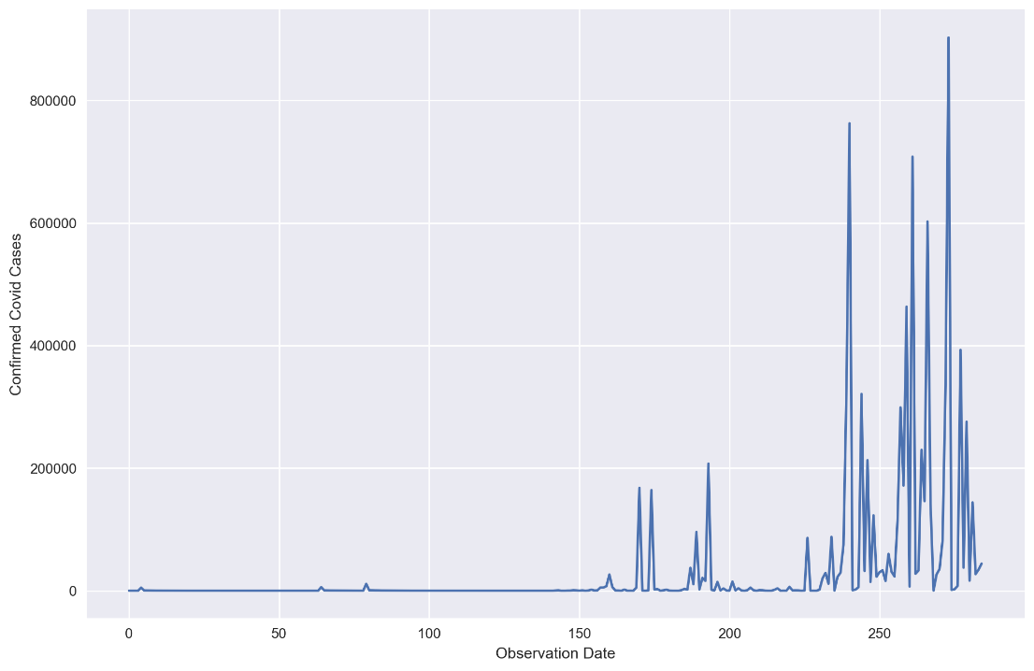
Figure: confirmed covid19 cases.
Converting dataset in float datatype, customizing the dataset dates because for covid19 dataset starts from 2020 to 2021.

Stationary Checking in the Covid19 dataset
To check either the dataset is stationary or not. Determine the dataset values that depends on the ratio of the data value.
Importing the python libraries such as: statsmodels.stattools import adfuller and determine the p-value of the dataset as follows:
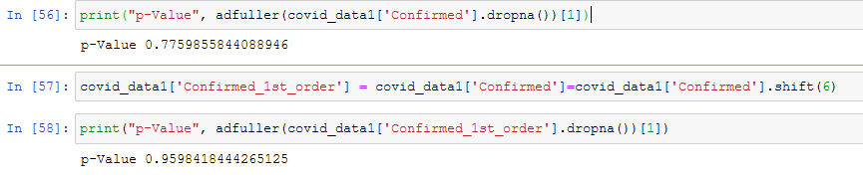
Figure: P –value determination

Determination of auto correlation value which used to identify the values in the given dataset. Determine the first order and second order auto correlation values of the confirmed covid19 cases. As follows:
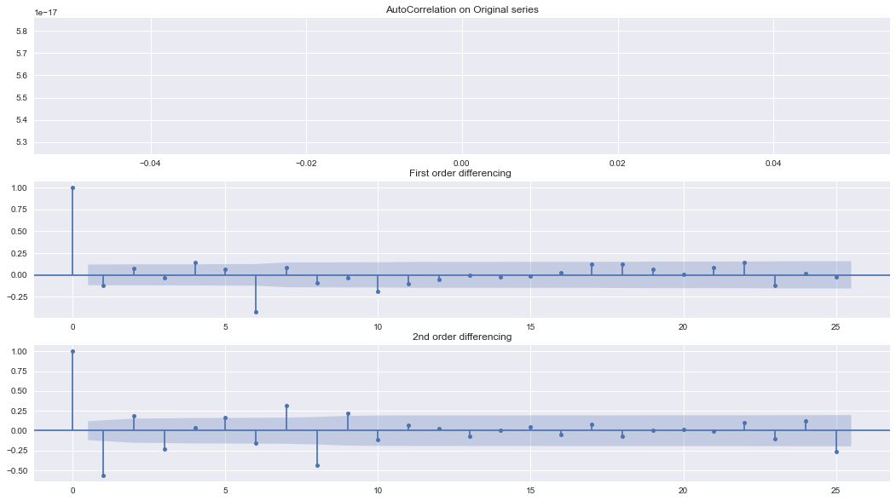
Figure: Autocorrelation plot of first order and second order differencing value in dataset.

Building the ARIMA Model Function
Importing the following ARIMA model libraries in jupyter notebook as follows:
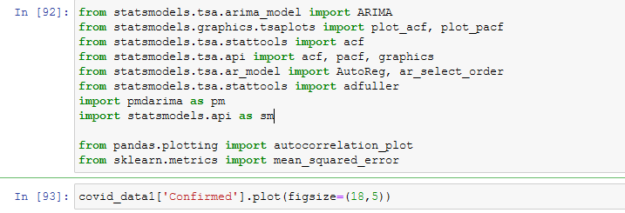
Figure: libraries and data value.

Plot the values of confirmed covid19 cases as below:

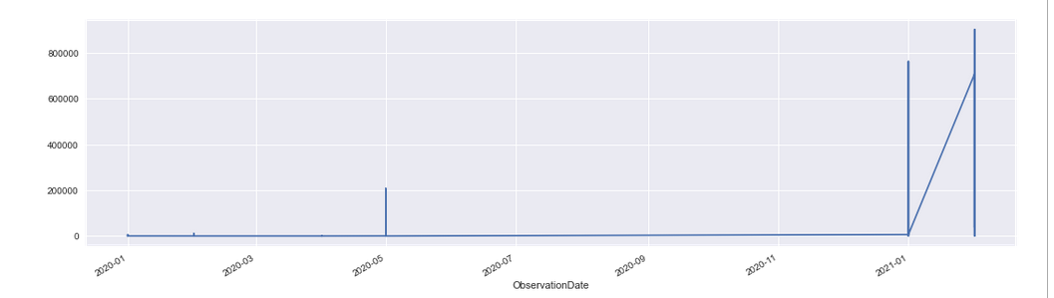
Figure: confirmed cases with observation date

Building the ARIMA Model:
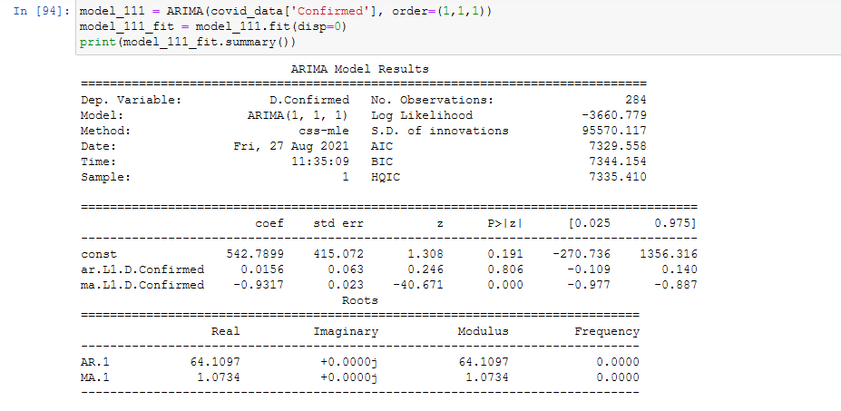
Figure: ARIMA Model

Plot the DENSITY value and Residual Error in dataset
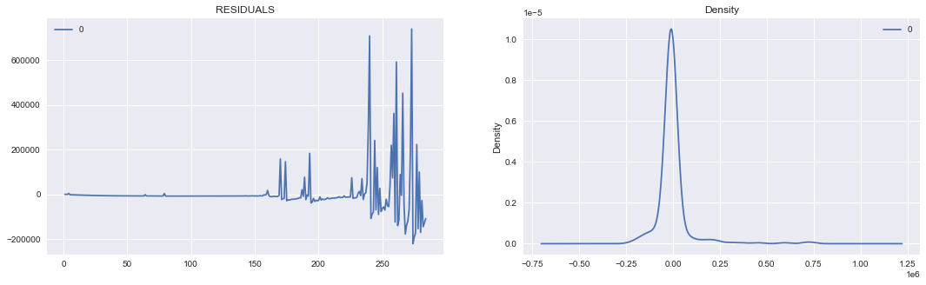
Figure: Residuals and Density
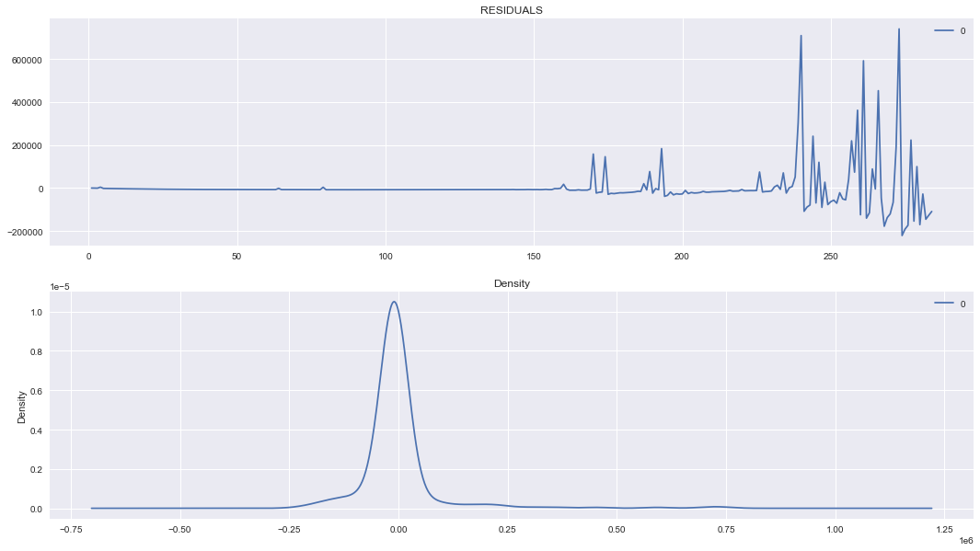
Figure: change the value of density plot

Actual vs. fitted ARIMA model:
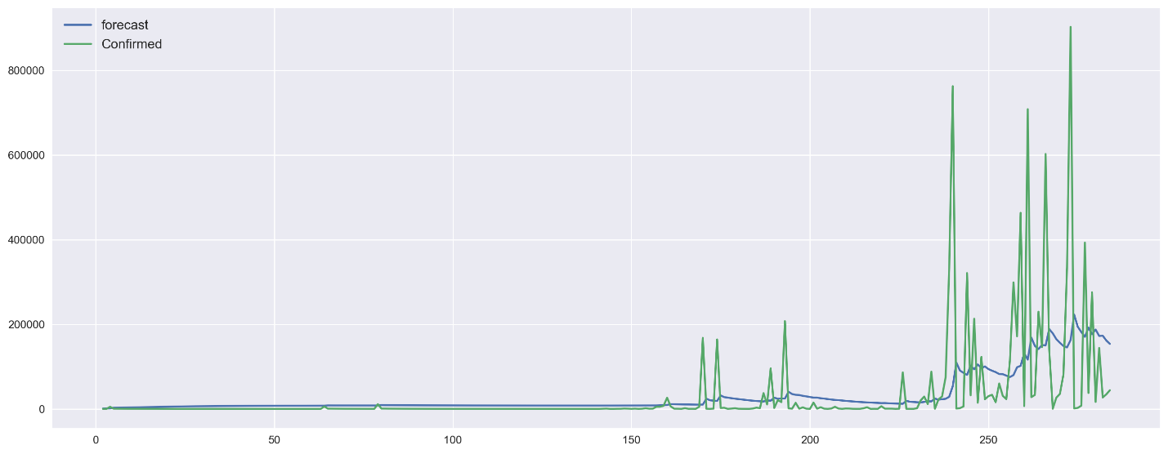
Figure: Forecast of confirmed cases.

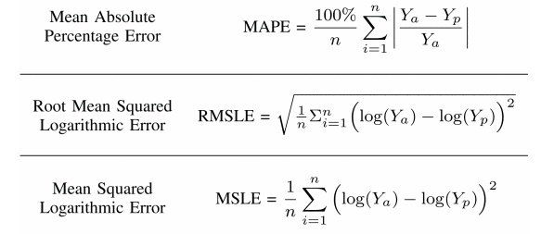
Figure: Error Measures

Analysis
Auto regressive integrated moving averages (ARIMA) model used to predict and evaluate the covid19 patient. It depends on the validation procedure. Dataset collected from March 2020 to April 2021. Sample dataset is selected only specific portion of the dataset has been used. The nonlinear auto regressive model using the neural network classification method. It used to predict the covid19 confirmed cases that based on the value of covid19 patient. ARIMA model also helps to predict the daily forecasting of covid patient. It directly connected with the dataset and evaluate the predictions on basis of appropriate modelling data level used in predicted variable in the dataset schemes. This model used to predict the monthly covid frequency level confirmed covid cases, which evaluate to select the specific portion of dataset based on date and confirmed covid method. The results show that the predicted value in increasing trends in the actual and forecasting trends of covid cases about to predict the approximate the values in the dataset which used to evaluate the resultant value by using the variable classification technique. The approximate covid19 cases about to 1600 cases per day that increasing on selecting the different country dataset. The appropriate ARIAM model has been selected to evaluate the Bayesian Information criteria which evaluate the overall highest values of 0.95%. The predicted NAR model which optimized the levenberg marquadrat optimization technique part of machine learning predictions (khan & gupta, 2020).
Outbreak of covid19 prediction evaluated with ARIMA prediction forecasting modeling based which predict the value concerned with the confirmed covid19 cases based on the observation date of given dataset. ARIMA model is known as auto ARIMA model. Assessment taken place from different countries, which ideally predict the values of confirmed covid19 cases based on dataset driven approach. The highly incident of covid patient that predict the values based on predicting modeling technique high forecasting technique efficiency matrix the index of increasing index which populate the resultant value. The index of increasing measured on mean absolute error (MAE) and root mean square error (RMSE) out of sample space in the dataset validate and predict the precision of model. The accuracy of ARIMA model is forecasting the future pandemic situation which will be proved to governance the system in more effective way. (Roy, et al., 2021).
Author proposed the ARIMA model based on mortality rates of covid on top six most affected counties of the world. Deployed genetic algorithm and auto regressive integrated moving averages technique, it was to deploy the moving average filter to evaluate the values in the dataset to achieve the accuracy result in the dataset. Reliable predicting model forecast the system that determine the public health and safety measures with the help of these models. Efficient technique to build the model which used to measure the x and y variable after training and testing dataset, into two portion. Genetic algorithm have the capabilities to improve the performance of ARIMA model. Optimized technique used to evaluate the modeling structure with the help of data driven approach. Optimization method based on genetic algorithm which model the ARIMA forecasting based on different time frequency. Tradition ARIMA model compare with other model which used to optimized the technique of differencing method. Similarly the combination of genetic algorithm and genetic algorithm can be used as alternative of each other that combine and separate the covid cases based on time period. It found the parameter of ARIMA prediction used by the data modeling. (Delief, et al., 2021).
Artificial intelligence researcher engaged to discover the answer the covid19 pandemic cases monitoring by using the Artificial intelligence technology in real time scenario. Also seeking the answer when this period over to collect the exact answer based on situational answer. The second order differencing method to collect the answer about to eradicate the period of pandemic situation. Expected to answer the question with the help to prior scan of virus monitor through the artificial intelligence scanning technology still not deploy to eradicate the situation. Author considered SARIMA model as compare to ARIMA model, SARIMA contains more efficiency and more stable results with different country dataset prediction. Proposed model of SARIMA used to predict the variable function. Based on the experimental results that show that the covid19 patient does not relate to achieve the accurate covid19 discovery to avoid the null and error frequency. (Malki, et al., 2020).

CNN (Convolutional Neural Network) Model

Importing Python Libraries

Numpy, keras, matplotlib.pyplot, import DENSE, import sequential

Data Pre-processing & Cleaning
Dataset import with CSV read files basically dataset is based on X-Ray images of covid-19 patient. Convolutional neural network modelling based on image dataset, on binary classification method, if the covid19 patient is confirmed it return the value 1 and if covid patient not covid patient then it return the 0 value.

Training & Testing dataset
Training the image data which contains two folder, confirmed x-ray image and not confirmed x-ray image.
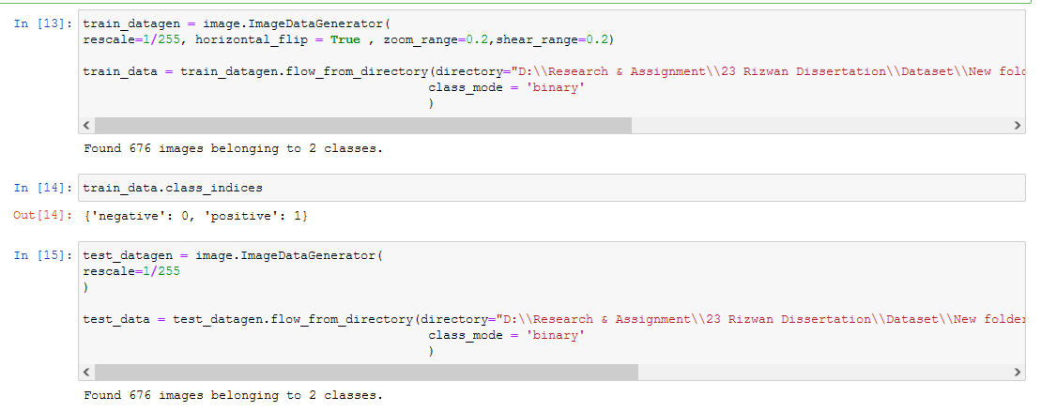
Figure: data training testing phase.
After importing the image dataset from the disk drive of system which contains the image data, because convolutional neural network algorithm performed on image dataset.
Next part is importing the convolutional neural network libraries. To build the sequential model of CNN as follow:

CNN (Convolutional Neural Network MODEL Summary)

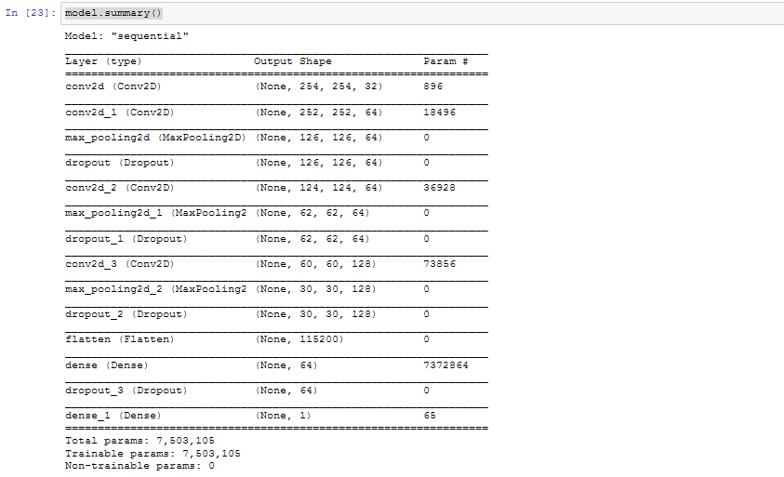
Figure: Convolutional neural network model

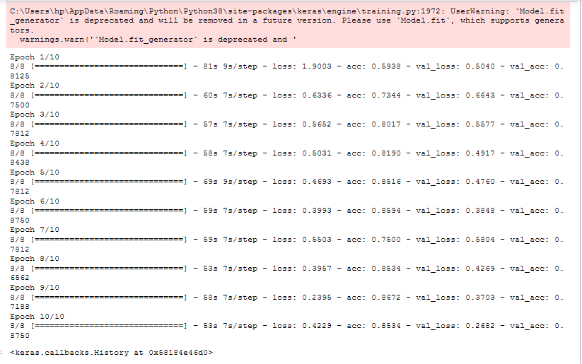
Figure: Keras Convolutional neural network EPOCHS

Determine the X-ray image is covid patient or not
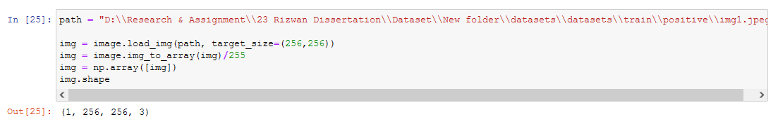
Figure image classification.

Analysis
Convolutional neural network classify to identity the circle of image, it applied on image segment and image region, CNN based on deep learning sequence, which used hidden layer function with the help of loopy circle with filter operation to identify the image. Convolutional operation based on loopy pattern detector and feature maps on diagonal line detector with vertical line detector. With the help of neural network feature extraction and classification technique applied by the convolutional neural networks. Neural network design based on training the neural network with database of image dataset. It predict the correct labels of test dataset which submit the predictions. Convolutional neural network produced accurate outcomes of image from the dataset. It shown the results based on computer aided diagnose system which is based on convolutional neural network, data collected from kaggle website, which is part of clinical trial dataset repository. It is considered that the performance of CNN is best accuracy result as compare to other deep learning prediction model. CNN algorithm which was trained on the clinical information that notably required the resources to prepare the CT images that experienced based on covid19 disease patient. The available data source is considered for evaluation and classify with image. The image is basically contains two parts one is covid19 detection patient and other is not confirmed covid19 patient. The dataset contain with X-Ray image. The properties of dataset has been collected with different framework to extract and validate the resultant value. The augmented data feature selection based on average accuracy of 97% accuracy is considered to be the great efficiency. To demonstrate the quality of image and its quality based on the data driven approach. The general method of classification technique that classify the system with image segmentation. Covid19 prediction has been tested through the multiple pre-trained deep models that founded on CT image. (Khozeimeh, et al., 2021)

This research aim is to predict and identify the covid confirmed cases ideally with top contrived that effected with covid19 mostly. CNN effort consumes applied manifold CNN replicas to categorize chest X-ray of pretentious patients through by their torso images. Rendering toward three replicas, the ResNet-50 is advantageous because of its high service reliability. (Mishra, et al., 2021), the artificial neural network used to classify the convolutional neural network images for a clinical dataset has been collected to identify the covid19 cases with the help of X-ray image. Convolutional neural network modeling technique used to monitor the 3D CT images, with the help of neural network training and testing the image model. Results show that the accuracy of identify the covid19 patient about to 95% accuracy with sensitivity of the data segment ratio. The risk of high potential with increasing level of event image that combine the dataset values. The developed model can be used to evaluate the aggressive classifier technique to evaluate the image segment system. (ho, et al., 2021).
Comparison between the non-linear auto regressive neural network model time series which used the covid19 forecasting technique has been evaluated with the functionality. Climbed Conjugate Incline (SCG), Levenberg Marquardt (LM) and Bayesian Regularization (BR) exercise procedures. The presentation of the future perfect consumes remained likened through by Root Mean Square Error (RMSE), Mean Square Error (MSE) and association co-efficient i.e. R-value. Their results show that the resultant value of machine learning algorithm prediction needs to be evaluated with the proper exercise and solution.

Chapter # 5 Discussion & Conclusion

Discussion
Covid19 dataset has been collected from different region and it will evaluated through the time series forecasting data prediction modeling technique. Time series forecasting prediction identify the problem of covid19 patient which is basically covid infected patient. The reason is that to hide the system of identification method which relate to evaluate the system boundary. Neural network architecture modeling technique efficiently used to deploy the systematic approach of identify the covid19 confirmed cases. Classification technique of neural network with image segmentation to predict the covid19 patient with image classification method of convolutional neural network approach is effectively used by many researcher to combine the results. The sequential model of identify the approach of ARIMA model and LSTM model configuration. Most commonly driven the LSTM model approach basically used to identify the modeling schemes. Kernel extreme classifier learning algorithm based on machine learning model structure. The main reason to identify the accuracy of the mean square error which was used to evaluate the data segment structure. (khan, et al., 2021).
Chest X-ray image is easily available because it is most easy and least expensive option for image data collection , the method of data collection is open source repository part of kaggle and other is machine learning repository, the machine learning mystery contain many data set repository of covid disease. Imaging dataset with X-Ray image that available on different repository scheme. Deep convolutional neural network based approach is highly recommended by the researcher. Convolutional neural network model Dense resnet and inceptive option is very useful technique that implemented in this work. Convolutional neural network model combines the other density function which is used to evaluate the higher precision rate of covid patient images. X-ray image of covid19 patient with +ve and –ve cases which validate with the binary sequence like 0 and 1. Covid19 patient pretended to achieve the better results with dividing the dataset into training and testing set of images. The methodology of Convolutional neural network obtain the great efficiency with great highest rates. The benchmark algorithm technique determine the frequency level in more advance form. The convolutional neural network determine the frequency level in more productive manner. GUI based CNN modelling technique more effectively work to identify the dataset and working problem of the people community which relates to the data set. Various researcher deploy the +v image of dataset and –v image of dataset to identify the covid patient where relate to determine the approach. (Das, et al., 2021).

Convolutional neural network, LSTM and ARIMA modelling technique validate the resultant value of covid19 prediction which relates to identify the disease and confirmed cases and death causes with different attribute of the dataset. These three combination considered more effectively that relates to the approach of time series analysis, which reflect the dataset would be based on validation process such as training, testing process. Dataset of covid19 images which change the level of predictions and observed value on different weekly component and vice versa. Furthermore the X-Ray image adjusted on the scale of binary scale parameters and identified with 2 parameters of covid19 disease detection such as positive patient and negative patient, by using the auto regressive integrated moving average model the mean square error with smoothing methods which predict the diseases patient on time series level. The combination of this strategies which provide the better prediction channel to individually deploy the methods with each other. This research work experimentations include the adjustment of the limits of the procedures. It likened the finest mixture approaches got by convolutional neural network with separate CNN, Extended Temporary Reminiscence (LSTM), ARIMA, and ES approaches. Consequences demonstration the cross technique exceeds the presentation of LSTM, and that it reliably attains modest consequences in footings of the MAPE metric, as opposite toward the separate CNN and ARIMA approaches, there presentation differs mainly aimed at dissimilar situations. (solis, et al., 2021).
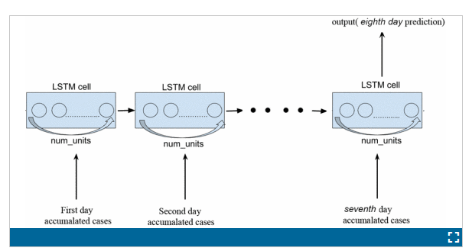
Figure: LSTM Architecture
Auto regressive integrated moving average model predict the number of covid19 cases and deep learning prediction model would be used to deploy the disease detection and prediction which based on evaluation method. ARIMA model known as generalized auto regressive model which determine the level of frequency domain with reflection of dataset. The long short term memory model which is internally located in the study that identify the modelling procedure. Mean squared error respectively measured with 75 to 80% time series frequency of time series model. The experiment results show that the percentage of improvement model to forecast the results of confirmed covid cases likely to be detected on 80% to 90% accuracy rate. Various datasets has been collected from open source system. The dataset approach for predicting analyzing after possible of training and testing models of frequency level. Mostly the ARIMA model is more useful to detecting corona virus cases on daily basis. The criteria of identified modelling technique which is preferable for the researcher to do ore effort for making results in more details. LSTM model get attention of the statistical modelling results with different time series prediction is much highly appreciated. ARIMA model identified the best possible statistical modeling prediction level on time series forecasting of different level, auto regressive model also predict the mean square error about the validity process of systematically approach. Convolutional neural network approach works on statistical modelling approach that relate to identify images, image dataset is labeled with positive and negative corona virus cases. (Kim, 2021).
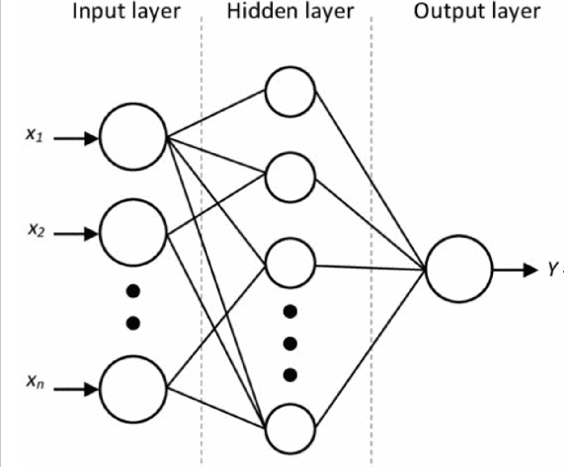
Figure: Neural network layer
The spread of covid19 cases striking to the human lives damage in more consistent manner all over world, the level of predicting the covid cases was very low but due to the minimal usages of artificial intelligence, the role of artificial intelligence need to deploy for detecting and analyzing them in more appropriate order. Advance covid19 predicting functionality with advance of short term and long term time series analysis was effectively used but the issue is that the implementation of statistical modelling technique was not much easy to deploy thing in more suitable way. Originally, statistics pre-processing then detail removal remains complete by the actual domain COVID-19 dataset. Then, the forecast of increasing long-established, demise and healthier worldwide circumstances remain demonstrated by Auto-Regressive Integrated Moving Average (ARIMA), Long Short-Term Memory (LSTM), Stacked Long Short-Term Memory (SLSTM) and Prophet approaches. The LSTM model works with neural network modelling technique that relate to identify them with feature extraction and feature selection methods. Dataset about to identify the correlation variable which reflect ideally on them to do the training set and testing set of the data which used to monitor the confirmed covid cases.
LSTM model and ARIMA model, Convolutional neural network model used in this research to predict to covid19 cases with the data set, it is recommended that the convolutional neural network model prediction is much better as compare to other model because it predicts the covid positive and negative cases over the image data set of X-Ray image. Covid19 cases prediction by monthly frequency of the covid infected patient. CNN model predict the image with the label of binary frequency such as if the image is covid infected the it’s predict to 1 value and if the image is not covid positive then its return 0 value. Machine learning algorithm widely used in this case for prediction covid cases as compare to the other models, the covid cases increases day by day in the mid-2020. For linear time series modeling the ARIMA model is widely used by many countries to forecast covid cases in the health department to eradicate the disease. ARIMA model contain auto regressive integrated mean square error algorithm, it basically a part of deep learning algorithm. Deep learning algorithm has been used recently due to its perfect measurement of variable. Deep learning measurements is basically used to overcome many challenges and issues. The task of time series forecasting and spatial time series forecasting has been measured to predict the cases. The time series forecasting in the past basically a part of statistics modelling, now the statistics embed in the machine learning and deep learning algorithm. The algorithm of long short term memory which is part of recurrent neural network they extracts similarities between sequential input by using three gates, forget gate, input gate, and output gate. LSTM cell is basically a part of these three gates LSTM contains several input layers and output layers. CNN (Convolutional neural network) gain more popularity as compare to ARIMA and LSTM for forecasting the image dataset. It predict the corona virus cases with the help of image dataset, after that a nonlinear function has been applied. Artificial neural network model predict the dataset with input layer and in the input layer contains many hidden layer which predict the actual and fake covid cases with respect of time forecasting results. Though ANN fixes not smear a group of the neighbor archives similar CNN neither usages the preceding standards happening the similar method as LSTM, it delivers sensible outcomes. (Istaitah, et al., 2020).
The best score of minimizing the covid cases in china due to forecasting the covid cases results by using the artificial intelligence deep learning algorithm such as Convolutional neural network model and ARIMA model and LSTM model with the effect of these changes the machine learning predicting algorithm challenges can be used solve the complex problem. ARIMA Model and LSTM model used to forecast the covid cased to predict the death ratio and confirmed covid cases as compare to other model these forecasting can help a lot for making decision and making challenging perspective to take intuitive to minimize the ratio of covid cases. Time series predictions for assessment of death ratio as well as confirmed covid cases to predict the values of covid cases. The performance of model has been predicted by the level of mean square error and the majority of the cases has been detected with LSTM model frequency. (Shahid, et al., 2020).
The time series models of ARIMA and LSTM modeling has been widely used to predict the time series frequency. K-period performance measurements predict the accuracy of covid19 cases which is evaluated through the mean square error which is identified the each value of patient during the pandemic situation. Beside this ARIMA takes long time to predict the values in the dataset but the modelling procedure of LSTM taking more effort for producing the accurate results as compare to the ARIMA , but the influence of ARIMA model is take a while to do the prediction and time series forecasting. Covid19 prediction and assessment these models can be helpful for the Gov. Organization because the development of modelling procedure to do the validation procedures which is used to measure the time series forecasting with better result. (Barman, 2020).
The 5000 images used for covid19 cases for the prediction of covid19 cases with the deep learning algorithm to predict and analyze the image data with Convolutional neural network. It prediction efficiency is best as compare to LSTM and ARIMA modelling. It predict the actual covid cases with image positive cases and negative cases. The dataset of pneumonia patient has been collected which would later identify the covid infected patient for classify the images by using the different time frequency. Training with GDCNN from the beginning to proposed method of predictions of measurement and analyzing them to evaluate the incidence of covid patient. Classification accuracy about to predict the covid19 cases such as 98% to 99% good accuracy of convolutional neural network performance is great with the CT- X-ray image of covid disease patient. The classification accuracy of neural networks to predict and evaluate the result with the image dataset is best option for making the analysis in more organized order. The specifying results of covid patient which would be predicting the result as compare to the covid patient disease measuring with CNN algorithm strong suggested by many researchers and concluded remarks by the research scholars because determining efficiency of convolutional neural network very much great as compare to other model. (Babukarthik, et al., 2020)
Convolutional neural network (CNN) abstracts the features in the chest x-ray images for prediction of covid patient. There are three filters applies to detect the image such as to detect the edges of the image that help to get the desire results of the infected area of chest, to detect and evaluate the image with keras image data generator is used to generate thousands of images from the image database such normal people, pneumonia people, virus infected people, and the outcomes show with convolutional neural network to detect the covid affected patient to evaluate the covid patient with great efficiency. (umer, et al., 2021)

Future Challenges of Prediction Modelling
The major issue to maintain the corona virus infected patient, uncertainty the patient alive and corona virus permitted with negative covid report, the concerned is to achieve the goal of successfully deploy the covid vaccination to avoid the covid spread in upcoming days. Machine learning methods has been strongly recommended by the many research scholars. Deep learning prediction model has been used in this research. Deep learning method describe the efficiency of dataset with neural network algorithm. Convolutional neural network, recurrent neural network artificial neural network integrated with many hidden layers of neuron. Neural network architecture copies the human brain architecture. The efficiency of detecting and predicting covid cases with image dataset is highly appreciated due to detection and outcomes results is much better than other model. (Ahmed, et al., 2021).
The SARS-COV2 19 spread rapidly all over the world, and damage human life very badly. Many researchers of various countries recommended deep learning method to predict and analyzed covid19 patient with the recent dataset. Basically predictions and forecasting helps health department to take decision about to eradication the situation and control the environment. Deep learning methods for predicting the cases with the help of X-ray images to detect the covid cases of pandemic situation. Various researchers show that machine learning methods for predicting and analyzing covid patient is highly appreciated specifically CNN convolutional neural network is much appreciated for developing the predicting model. The future challenges exist for detecting and predicting the covid19 patient in real time scenarios, there is a need to develop the real time situation artificial intelligence based software technology that detect and predict the covid19 cases in crown public places. This tool may be costly but the development would be helpful for the public health department to take decision rapidly and minimize the situation without any vaccination pre-cautions messages. The future challenge for developing real time software at public places to minimize the covid cases, the person is detected with the body language and their body temperature. (Alafif, et al., 2021).

Conclusion
The concluded remarks of this research is convolutional neural network of deep learning method is strongly recommended due to its great efficiency of covid disease detection of patient. Convolutional neural networks works with hidden layers of neural network, it copies the human brain architecture models, this models rapidly deploy by many researchers in these days. The popularity of convolutional neural network is that the loopy circle and filter operation to perform convolutional operation with the image and detect the edge and circle and shape in the image with separate region and divides each region to multiple hidden region to produce the great accuracy, such as the person is covid positive or not. The features of neural network convolutional neural network is that the loopy pattern detector including with feature maps with diagonal line detector to detect the image and the vertical line detector can be used to extract the feature and classify the image with millions and billions of hidden neural layers. There are the univariate forecasting and multivariate forecasting auto regressive moving averages forecasting to predict and plot the covid patient series with different period of year. Neural network training with the datasets for making the prediction with feature scaling procedure to divide the each layer testing and training potion of dataset. In this research three model is used ARIMA, LSTM and convolutional neural network. The recommendation is use convolutional neural network model because the great efficiency of covid detection. Future research work is required to develop real time software with deep learning methods at public places to detect the human body temperature and analyze them with body language of the person. Ethical concern is maintain in this research, no human being is harm and violate in this research.

References
Abdelhafid, Harrou, F. & dairi, A., 2020. Deep learning methods for forecasting covid19 time series data a comparative study. Chaos Solitons & Fractils, Volume 140, p. 1.
Adikari, A., Nawarantne, R. & silva, D. d., 2021. Emotions of Covid19 : content analysis of self reported information using artificial intelligence. JMIR Punlications, 23(4), p. 1.
Ahmed, A., Garhwal, S. & Ray, S. k., 2021. The number of confirmed cases of covid19 by using machine learning methods and challenges. Arch Computation methods Engineering, p. 28.
AI, 3.-W. o. C. i. t. a. a. a., 2021. 3-Ways of Covid19 is transforming advanced analytics and AI. [Online]
Available at: https://www.waveforum.org/agenda/2020/07/3/3-ways-of-covid19-is-transforming-advanced-analytics-ai
[Accessed 12 August 2021].
Alafif, T., Muneeim, A. & Bajaba, S., 2021. Machine and deep learning towards covid19 diagnosis and treatment: survey, challenges and future directions. Environmental research and public health, 18(3), p. 1.
Alazab, M., Awajan, A. & Abdelwadood, 2020. COVID19 prediction and detection using deep learning. international journal of computer information system and industrial management applications, Volume 12, pp. 168-181.
Analytics, H. I., 2020. Could Covid19 Help Refine AI Data analytics in Healthcare. [Online]
Available at: https://healthanalytics.com/features/could-covid-19-help-refine--ai-data-analytics-in-healthcare
[Accessed 12 August 2021].
Anoushi, K. E. & Chawaki, Y., 2021. Using X-Ray images and deep learning for automated detection of corona virus disease. Journal of Biomolecular structure and dynamics, 39(10), p. 2.
ASRS, R. & JA, V., 2020. Identification of COVID19 can be a quicker through the artificial intelligence framework using a mobile phone based survey in the populations when cities town under quarantine. Infection control Hospital, pp. 1-18.
Babukarthik, R., Adiga, V. A. K. & G.Sambasivam, 2020. Prediction of covid19 using genetic deep learning convolutional neural network. IEEE Access, Volume 8, pp. 177647-177666.
Bamidele, J., Oluwakhola, S. & Gbenaga, R., 2021. Application of artificial intelligence for covid19 epedimic an exploratory study opportunities challenges and future prospect. Artificial intelligence for covid19, pp. 47-61.
Bansal, A., Paddpayle, R. P. & Garg, C., 2020. Utility of Artificial intelligence Admist the COVID19 pandemic : A Review. Journal of Medical System, Volume 156, p. 44.
Barman, A., 2020. Time Series analysis and forcasting of covid19 cases using LSTM and ARIMA models. machine learning and computer science cornell university, p. 1.
Barnawi, A., chikaara, P. & Rajkumar, 2021. Artificial intelligence enabled internet of things based system for covid19 screening using aerial thermal imaging. future generation computer systems, Volume 124, pp. 119-132.
Behera, R. K., jena, M. & Rath, S. k., 2021. Co-LSTM: Convulutional LSTM models for sentiment analysis in socail big data. Information processing & Management, 58(1), p. 1.
Besancon, L., Smadja, N. p. & Segalas, C., 2021. open science saves lives: lesson from the covid19 pandemic. BMC medical research methdology, pp. 21-117.
Borra, S., 2020. Covid-19 APP Privacy and Security Concerns. Intelligent system and methods to combat covid 19, pp. 11-17.
Bragazzi, N. L., Dai, H. & Giovani, 2020. How big data and artificial intelligence can help better manage the covid 19 pandemic. Environmental research and public health, 17(9), p. 1.
C., J. D. S., 2020. Artificial intellience enabled robotic drones for covid-19 outbreak. intelligent system and methods to combat covid-19 springer briefs in applied science and technology, pp. 37-46.
CJ, W., CY, N. & RH, B., 2020. Response to covid19 in Taiwan : big data analytics, new technology and proactive testing. JAMA Internet , p. 1.
Darapaneni, N., Reddy, D. & Paduri, A. r., 2020. Forecasting of covid19 in india using ARIMA model. 2020 11th International IEEE Annual Uniquotous electronics and mobile communication conference, pp. 0894-0899.
Das, A. K., ghosh, S. & thunder, S., 2021. Automatic Covid-19 detection from x-ray images using ensembled learning with convolutional neural network. Pattern analysis and applications, Volume 24, p. 1.
Delief, M. A., Solyman, A. A. & E, R., 2021. ARIMA model estimation based on genetic algortihm for covid19 mortality rates. international journal of information technology & decision making , p. 1.
Dong, J., Wu, H. & Zhou, D., 2021. Application of big data and artificial intelligence in covid19 prevention diagnosis treatment and management decisions in china. Systems level quality improvement , 45(84), p. 1.
Due, D. E. & L, G., 2020. an interactive web based dashboard to track covid19 in real time. Lancent Infect Dis, p. 1.
Edem, I., Osita, B. & Beti, A., 2020. Review of Big data analytics artificial intelligence and nature inspired computing models towards accurate detection of COVID 19 Pandemic cases and contact tracing. Environmental Research and Public health, 17(15), p. 1.
Elghamrawy, S., 2020. An H2O's Deep learning inspired modelling based on big data analytics for corona virus disease covid 19 diagnosis. Big data analytics and artificial intelligene against covid19 innovation vision and approach, pp. 263-279.
G.L, Z., AM, K. & KN, S., 2005. Neural models for predicting viral vaccine targets. journal of bioinforma computer biologocial science, 1(3), pp. 1207-1210.
ghour, M. & Jain, S., 2020. Stacked Convolutional neural network for diagnosis of covid19 disease from x-ray images. Electrical engineering and system sciences images and video processing, p. 1.
Ginnekan, B. V., 2020. The potential of artificial intelligence to analyze chest radiographs for signs of covid19 penumenia. Radiology, p. 1.
H.H, T., Alrasheed, M. & Abdullah, A., 2020. Deep learning and holt trend algorithms for predicting covid19 pandemic. medrxiv journal, p. 1.
ho, T. T., park, J. & kim, T., 2021. Deep learning models for predicting severe progression in covid19 infected patients retrospective study. JMIR publications, 9(1), p. 1.
Huang, C.-J., Chen, Y. H. & Ma, Y., 2020. Multiple input convolutional neural network model for covid19 forecasting in china. Medrxiv the preprint server for health sciences, p. 1.
Huges, A., 2020. Artificial intelligence enabled health care delivery and real time medical data analytics in monitoring detecting prevention covid 19. Americal Journal of medical science, Issue 2, pp. 50-56.
Hussain, A., tahir, A. & hussain, z., 2021. Artificial intelligence enabled analysis of public attributes on facebook and twitter toward covid19 vaccines in the united kingdom and united states observational study. JMIR publications, 23(4), p. 1.
Istaitah, O., Owais, T. & Al-maidi, N., 2020. Machine learning approaches for COVID19 forecasting. 2020 international conference on intelligent data science technologies and applications (IDSTA) , pp. 50-57.
Jalal A, A. M. l. &. N., 2020. Machine Learning & NLP used in biosurvellience and public health practice. online public health journal, Volume 1, p. 7.
Kaur, I., Behl, T. & Aleya, L., 2021. Artificial intelligence as a fundemental tool in management of infectious disease and its current implementation of covid19 pandemic. Environmental factors and Epidemics of covid19, Volume 28, pp. 40515-40532.
khan, F. m. & gupta, R., 2020. ARIMA and NAR based prediction model for time series analysis of covid19 cases in india. Journal of Safety science and resilience, 1(1), pp. 12-18.
khan, M. A., Kadry, S. & Akram, T., 2021. Prediction of covid19 based on selected deep features and one class kernel extreme learning machine. computers and electrical engineering, p. 1.
khan, M., tariq, M. & haq, Z. u., 2021. Application of artificial intelligence in covid19 pandemic a comprehensive review. expert systems with applications , 15(115695), p. 11.
Kharlamov, A. A., N., A. & Pilgun, M., 2021. Smart city data sensing during covid19 public reaction to accelerating digital transformation. MDPI Research Journal, 21(12), p. 1.
Khozeimeh, F., Sharirazi, D. & Zaidi, N. H., 2021. Combining a convolutional neural network with autoencoders to predict the survival chance of covid19 patient. scientific reports, p. 1.
Kim, M., 2021. Prediction of covid19 confirmed cases after vaccination based on statistical and deep learning models. SciMedical Journal, 3(2), p. 1.
K, M., VS, M. & P, M., 2016. Developing global norms for sharing data and results during publich health emergence. Medical Science Journal, 13(1), p. 5.
Kumar, A., Gupta, P. K. & Srivastave, A., 2020. A review of modern technologies for tacking covid 19 pandemic. Diabeties & metabolic syndrome clinical research review, 14(4), pp. 569-573.
Kumar, V. & Zhang, L., 2020. Time Series forecasting of covid19 transmission in canada using LSTM networks. Chaos, Solitons & Fractals, Volume 135, p. 1.
M.H, R. & F, S. M. O., 2019. Risk assessment of ebola virus disease spreading in uganda using a two layer temporal model network. Science Direct SCI REP, 5(9), pp. 1-17.
MA, A., MS, K., KD, V. & J, M., 2020. Machine Learning & NLP. BioSurvelliance and public health practice, p. 1.
Mahalle, P. N., Sable, N. P. & P, N., 2020. Data analytics covid 19 prediction using multi model data. Chicago: s.n.
majid, S., Farooq, r. & Khan, M. S., 2021. Managing the covid19 pandemic research strategies based on the evolutionary and molecular characterstics of corona virus. Springer link, p. 1.
Malki, Z., Atlam, E.-S. & Ewis, A., 2020. ARIMA models for predicting the end of covid19 panademic and the risk of second rebound. Neural computing and applications, Volume 1, pp. 2929-2948.
Mishra, J., tiwari, M. & Bajpai, B., 2021. Covid19 prediction through x-ray images using various layers in convolutional neural network. emarld insight, p. 1.
Modgil, S., Singh, R. K. & Claire, 2021. Artificial intelligence for supply chain resilience: learning form Covid19. The International Journal of Logistics Managment, p. 1.
Mohammadou, Y., Halidou, A. & Diam, P., 2020. a review of mathematical modelling, artificial intelligence and datasets used in the study prediction and management of covid19. Applied intelligence, Volume 50, pp. 3913-3925.
Mu, W., Zhang, A. & Zaho, W., 2020. Application of ARIMA model in fault diagnosis of TEP. 2020 IEEE 9th Data driven control and learning systems conference (DDCLS) , pp. 393-398.
M, W. & M, P. L. .., 2021. Methodological challenges of analysing covid19 data during the pandemic situation of the world. BMC Medical research methdological research, p. 1.
Mystery, M. L., 2021. Machine learning mystery. [Online]
Available at: http://www.machinelearningmystery.com/LSTML-model
[Accessed 23rd August 2021].
Naude, W., 2020. Artificial intelligence against covid19 an early review. IZA disucussion paper no 13110 at SRRN, p. 13110.
Nougeria, R. G., M, J. & gupta, R., 2021. Epidemiological Surveillance of the impact of the covid19 pandemic on stroke care using artificial intelligence. Epidemiological Surveillance of the impact of the covid19 pandemic, 52(4), p. 1.
ortiz, D. M., Contreras, S. & saavedra, Y. b., 2020. country wise forecast model for the effective reproduction number Rt of corona virus disease. frontier in physics journal, p. 1.
parbat, D. & Chakarborty, M., 2020. a python based support vector regression model for prediction of covid19 cases in india. Chaos Solitons & Fractals, p. 10992.
Pham, Q.-V., Nugyuan, D. C. & Thein, 2021. Artificial intelligence and big data for coronavirus covid19 pandemic a survey on the state of the art. IEEE Access Journal, p. 19.
Punn, N. S., Sonbahdura, S. K. & Agarwal, S., 2020. COVID19 Epidemic Analysis using machine learning and deep learning algorithm. medrxiv journal, p. 1.
Rahmiatahzadha, S., Saidha & Ali, 2020. The role of artificial intelligence in management of critical covid19 patients. Journal of Cellular and Molecullar Anesthesia, p. 1.
Raza, K., 2020. Artificial intelligence Against COVID 19 A meta analysis of current research. Big data analytics and artificial intelligence against covid 19 innovation vision and approach, pp. 165-176.
Roy, S., Bhunia, G. S. & shit, P. k., 2021. Spatial prediction of covid19 epidemic using ariam techniques in india. Modeling earth systems and environment, pp. 1385-1391.
Shahid, F., Zameer, A. & Muneeb, M., 2020. Predictions of covid 19 with deep learning models of LSTM GRU and Bi LSTM. Chaos Solitons & Fractals , p. 1.
S, M., V.R, N. & P.S, R., 2020. Pervasive computing in the context of covid19 prediction with AI based algorithms. emerald insight journal, 16(5), p. 1.
solis, J. F., Gonzialez, L. J. H. & Gonzualz, J. J., 2021. Convolutional neural network component transformation (CNN-CT) for confirmed covid19 cases. Mathematical and computational application, 2(29), p. 26.
Soltan, A. A. S., Chirr, M., Kauchaki, S. & DPhil, T. Z., 2021. Rapid triage for covid19 using routine clinical data for patients attending hospital development and prespective validation of an artificial intelligence screeing test. The Lancent Health, 3(2), p. 1.
SR, V., A, T. & RN, G., 2019. Data driven model for real time influenza forecasting. IEEE ACCESS, Volume 7, pp. 7691-7695.
Suhermi, N., Suhartono & Prastyo, D. D., 2018. Roll motion prediction using a hybrid deep learning and ARIMA model. Procedia Computer Science, Volume 144, pp. 251-258.
S, W., B, K. & X, M. j. Z., 2020. A deep learning algorithm by using CT images to screen for corona virus disease (covid19). MedRxiv Journal, p. 1.
Tian, Y., Luthra, I. & Zhang, X., 2020. Forecasting covid19 cases using the machine learning models. MedRexiv the preprint server for health scieces, p. 1.
umer, M., ashraf, i. & Ullah, S., 2021. COVIVNet: a convolutional neural network approach for predicting covid19 from chest X-Ray images. Springer Link: Ambient intelligent Human computing, p. 1.
Verbeke, A., 2021. a few implications of the COVID19 Pandemic for international business strategy research. Univesity of Brussel, p. 1.
Visva, D., Marjorie, R. & thum, Y. C., 2021. Application of digital health for publich health responsis to covid19 a systemetic scoping review of artificial intelligence telehealth and related technologies. Open Access Journal , p. 40.
Wang, S., Kang, B. & Ma, J., 2021. A deep learning algorithm using CT images to screen for corona virus disease covid19. Imaging informatics and artificial intelligence , Volume 31, pp. 6096-6104.
Zou, M., Khosa, S. K. & Ahmed, Z., 2020. comparison of covid19 pandemics dynamics in Asian countries with statistical modelling. computational and mathematical methods in medicine, Volume , p. 1.

Reflection

The research is pure quality work of artificial intelligence based machine learning and deep learning algorithm. I learns a lot during writing this research many deep learning algorithm libraries help me to do my work in more organized manner. This research is highlight the covid disease detection by using deep learning algorithm. Deep learning and recurrent neural network currently the hot research topic in these days. Convolutional neural network algorithm is more convenient way to organize and manage this data analytics in appropriate manner. In my consideration ARIMA model and LSTM model and convolutional neural network will be helpful for health department for detecting covid disease patient. The time series forecasting model of ARIMA pure statistical related forecasting model. My opinion is to deploy these algorithm in health department of Govt. organization.

Research Experience
My personal experience for making this project in more organized manner for learning machine learning and deep learning algorithm, by using python IDE such as Jupiter notebook and anaconda IDE for making machine learning and deep learning algorithm. Jupiter notebook is open source python IDE which would be helpful for me for taking the decision to build LSTM model by data pre-processing method, importing python libraries, data cleaning process, data manipulation process for testing and training by using machine learning algorithm. By building ARIMA model and by making convolutional neural network. This would be really appreciated by the difference research scholars for deploying convolutional neural network algorithm to classify the image data segment. My research experience for detecting covid disease patient by using dataset which is downloaded from Kaggle open source machine learning repository. This was amazing experience for me.

Teacher Meetings
My teacher always suggest me the best advice for making things in more advance and reliable manner. This would be really helpful for me to making this work more unique and more organized by collecting many ideas and many suggestion for my teacher to do this work in this way. This was a gift of God. It was very helpful for me to taking my work in such a positive direction.

Skills Development
I have learns a lot for building machine learning and deep learning based model it would really helpful for me for building the ARIMA model and LSTM model and convolutional neural network based modelling technique is very useful for making this work more organize. For making data analysis part its very learning part for me.

Research idea & development
Research idea is basically suggest by my mentors. This will be really helpful for me.

Research work process
This research work is divided in two phase such as.
- For making python based analysis by using ARIMA Model, LSTM model and convolutional model by using Python Anaconda IDE. Primary data
- Secondary work is to use to write up literature review and data analysis, discussion, method, conclusion. This research work in not copyright of anyone else, secondly the resources using in this research by other author work it is cited by their name and research journal name. this research work is maintain all ethical concerns.

